CFIHOS - Scope and Procedure 范围和程序

Acknowledgements 致谢
In 2012, Shell approached Netherlands-based process industry organization USPI to explore turning their corporate information standard into an industry-wide standard. The result was the CFIHOS (Capital Facilities Information Handover Specification) project.
壳牌于2012年与总部位于荷兰的流程工业组织USPI（荷兰流程工业协会）接洽，希望将其企业信息标准转化为行业标准，因而形成了CFIHOS（资产密集型设施信息移交规范）项目。
Its aim is to offer practical, standardized specifications for information handover that work across the supply chain – operators, contractors and suppliers. The most recent CFIHOS industry standard (Version 1.4) was published in October 2019 by USPI with support from the Engineering Advancement Association of Japan (ENAA). This document, describing the scope and procedures of CFIHOS, is part of this standard.
CFIHOS项目旨在为信息移交提供实用标准化规范，该规范适用于整个供应链——运行方、承包方和供应方。CFIHOS 1.4版是由USPI在ENAA（日本工程协会）支持下发布的最新版，于2019年10月发布。本文件描述CFIHOS的范围和程序，是该标准的一部分。
Following a member vote in 2019, the future governance, development, and maintenance of the CFIHOS project and standard moved from USPI to IOGP in January 2020, becoming Joint Industry Project (JIP) 36.
2019年经成员投票表决，CFIHOS项目和标准的未来治理、编制和维护于2020年1月从USPI移至IOGP（国际油气生产方协会），成为JIP36（第36号联合工业项目）。
Disclaimer 免责声明
Whilst every effort has been made to ensure the accuracy of the information contained in this publication, neither IOGP nor any of its Members past present or future warrants its accuracy or will, regardless of its or their negligence, assume liability for any foreseeable or unforeseeable use made thereof, which liability is hereby excluded. Consequently, such use is at the recipient’s own risk on the basis that any use by the recipient constitutes agreement to the terms of this disclaimer. The recipient is obliged to inform any subsequent recipient of such terms.
尽管已尽一切努力确保本出版物中所含信息的准确性，但IOGP及其任何成员过去现在或未来均不保证其准确性，或无论其疏忽，均不对任何可预见或不可预见的使用承担责任，特此排除这些责任。受方的任何使用均构成对本免责声明条款的同意，因此此类使用的风险由受方自行承担。受方有义务将此类条款通知任何后续受方。
This publication is made available for information purposes and solely for the private use of the user. IOGP will not directly or indirectly endorse, approve or accredit the content of any course, event or otherwise where this publication will be reproduced.
本出版物仅供参考，仅供用户自用。IOGP不会直接或间接认可、批准或授权将复制本出版物的任何课程、活动或其他。
Copyright notice 版权声明
The contents of these pages are © International Association of Oil & Gas Producers. Permission is given to reproduce this report in whole or in part provided (i) that the copyright of IOGP and (ii) the sources are acknowledged. All other rights are reserved. Any other use requires the prior written permission of IOGP.
各页内容版权由IOGP所有（© International Association of Oil & Gas Producers）。在 (i) IOGP的版权和 (ii) 来源得到承认的前提下允许全部或部分复制本报告。IOGP保留所有其他权利。任何其他用途都需要IOGP事先书面许可。
These Terms and Conditions shall be governed by and construed in accordance with the laws of England and Wales. Disputes arising here from shall be exclusively subject to the jurisdiction of the courts of England and Wales.
这些条款和条件应受英格兰和威尔士法律管辖并按其解释。由此产生的争议应仅受英格兰和威尔士法院的管辖。

CFIHOS - Scope and Procedures 范围和程序

Version 版本 | Date 日期 | Comments/History 备注/记录
1.4 | April 2020  2020年4月 | IOGP republication of CFIHOS document first published in October 2019.  IOGP对首次于2019年10月发布的CFIHOS文档的再版。
1.4.1 | December 2020  2020年12月 | Minor text changes in Section 5: ‘General Concepts and Principles’ to ensure continued alignment - following bug fixes to the CFIHOS Standard. The changes affect sub-points:  “5. 一般概念和原则”中文本的次要变更，以确保持续对齐——更正CFIHOS标准中的错误。变更影响子项：  5.4.2.3, 5.4.2.6 and 5.4.2.7,  5.4.3.1 and 5.4.3. 6  5.5.3.5  Change to Section 7: IT requirements  “7. IT要求”变更：  7.4 - suppliers defined to align with specification document 定义供应方以对齐CFIHOS规范
1.5 | October 2021  2021年10月 | Removed references to v1.4  删除了对v1.4的引用
1.5.1 | 2022-11  2022年11月 | Minor text changes for bug fixes throughout the text of the document  在本文件的整个文本中更正错误的次要文本变更。

Foreword 前言
The Capital Facilities Information Handover Specification (CFIHOS) is an industry standard developed to improve how information is exchanged between the companies who own, operate, and construct equipment for the process and energy sectors. Starting with a common equipment naming taxonomy and supporting specifications, its goal is to become a common language for the exchange of information in these sectors.
CFIHOS（资产密集型设施信息移交规范）是一项为改进流程与能源行业拥有、运行和制造设备的公司之间如何交换技术信息而制定的行业标准。CFIHOS始于公用设备命名分类法和支持规范，目标是成为流程与能源行业信息交换的公用语言。
The initial focus is on information, both structured data and traditional document formats, which must be handed over when a project moves from its development to operations phase. Ultimately, the aim is for CFIHOS to become the de-facto standard for information exchange throughout the physical asset lifecycle, from vendor information through to decommissioning.
CFIHOS起初关注的是项目从开发阶段进入运行阶段时必须移交的信息（结构化数据和传统文档格式）。CFIHOS终极目标是成为从供方信息至退役的整个物理资产生命周期信息交换的事实标准。
The Reference Data Library or “RDL” lies at CFIHOS’ heart. This library gives a standard and unified naming convention for equipment, its attributes, disciplines, and documents. The CFIHOS RDL includes:
- A list of classes for Tag and Equipment (what the equipment does and what it is)
- A list of properties (attributes, measures, characteristics etc.)
- Lists of requirements by class (data and document requirements)
- Standard unique coding of data to facilitate digital design and other workflows
- A list of document types
- A list of disciplines.
RDL（参考数据类库）是CFIHOS的核心，为设备及其属性、专业和文档提供一个标准且统一的命名规范。CFIHOS RDL包括：
- 位号和设备的类列表（设备及其功能）
- 特性列表（属性、计量、特征等）
- 按类的要求列表（数据和文档要求）
- 数据的标准唯一编码，以备数字化设计和其他工作流程使用
- 文档类型列表
- 专业列表
At present, CFIHOS covers only the exchange of structured data and documents - not graphical, geometry, and model data. In the future, CFIHOS could be extended to include graphical and design tool and support spare parts procurement, inspection, test requirements, commissioning check sheets, Work Packaging, configuration management, and even drive payment.
CFIHOS目前仅涵盖结构化数据和文档的交换，不涵盖图形、几何和模型数据。CFIHOS未来可能扩展至包括图形和设计工具，并支持备件采购要求、检验要求、试验要求、调试检查表、工作包、配置管理，乃至推动支付。
CFIHOS is being developed collaboratively by project members as a practical standard to ensure the systematic and reliable exchange of information between all participants involved in the information supply chain, thereby reducing cycle times and costs. More than 70 organizations contributed to the development of CFIHOS Standard, which is supported by several leading software industry design tools.
CFIHOS由项目成员作为实用标准协作编制，以确保信息供应链中涉及的所有参与方之间系统及可靠的信息交换，从而缩短周期并降低成本。CFIHOS标准参编组织超过70个，并得到一些软件行业领先设计工具支持。

Contents 目次
Foreword 前言 5
1. Introduction 介绍 11
1.1 General 总则 11
1.2 Scope 范围 11
1.3 Documents Structure 文档结构 12
2. Normative References 规范性引用文件 12
3. Terms and Definitions, Acronyms and Abbreviations 术语、定义、首字母缩略词和缩略语 13
4. Information Management Standards 信息管理标准 18
4.1 General 总则 18
4.2 Applicable Regulations and Standards 适用法规和标准 18
4.3 Project Reference Documents 项目参考文档 18
5. General Concepts and Principles 一般概念和原则 19
5.1 General 总则 19
5.2 Maturity of Information 信息成熟度 19
5.3 Information Life Cycle 信息生命周期 20
5.3.1 Information Suppliers and Information Consumers 信息提供方和信息使用方 21
5.3.2 Information Supply Chain Requirements and CFIHOS 信息供应链要求和CFIHOS 24
5.4 Capital Facility Information 资产密集型设施信息 26
5.4.1 General 总则 26
5.4.2 Capital Facility Documents 资产密集型设施文档 26
5.4.3 Capital Facility Data 资产密集型设施数据 29
5.5 Information Security 信息安全 33
6. Information Management 信息管理 34
6.1 Management of Data, Information, and Documents 数据、信息和文档管理 34
6.2 Project Information Management Implementation Plan 项目信息管理实施方案 34
6.3 Information Quality Management 信息质量管理 35
6.4 Information Security Management 信息安全管理 36
6.5 Facility Information Management 设施信息管理 36
6.5.1 Scope of Facility Information Management 设施信息管理的范围 36
6.5.2 Facility Document Management设施文档管理 37
6.5.3 Facility Data Management 设施数据管理 41
6.5.4 Data and Document Consistency Management 数据和文档一致性管理 44
6.6 Change Management 变更管理 44
6.6.1 Document Change Management 文档变更管理 45
6.6.2 Data Change Management 数据变更管理 45
6.7 Interface Management 接口管理 45
6.7.1 Correspondence Management 通信管理 45
6.7.2 Tie-Ins, Boundaries and Scope Management 连结、边界和范围管理 46
6.7.3 Workflow Principles 工作流程原则 46
6.8 Data/Information Governance 数据/信息治理 46
7. IT Requirements IT要求 48
7.1 Common Data Environment (CDE) 公用数据环境（CDE） 48
7.2 Applications used by Contractor 承包方使用的应用程序 48
8. IM Organization, Roles, and Responsibility IM组织、角色和职责 49
8.1 Stakeholders 利益相关方 49
8.1.1 Corporate Stakeholders 公司利益相关方 49
8.1.2 Internal Stakeholders 内部利益相关方 50
8.2 Information Interfaces among Stakeholders 利益相关方之间的信息接口 51
8.3 Information Review and Approval Responsibilities 信息复核和批准职责 52
8.4 IM Organizations and Functions IM组织和职能 52
8.4.1 Principal’s IM Organization 委托方IM组织 53
8.4.2 Contractor’s IM Organizations 承包方IM组织 53
8.4.3 Suppliers/Manufacturers’ and Subcontractors’ IM Organizations 供应方/制造方和分包方的IM组织 53
8.4.4 Joint IM Team 联合IM团队 53
8.5 IM Roles, Job Descriptions, Responsibilities, and Skill Sets IM角色、工作描述、职责和技能 54
8.5.1 General 概述 54
8.5.2 IM Roles IM角色 54
8.5.3 Data Owners and Data Stewards 数据所有者和数据管理者 54
9. Information Management Process and Activities 信息管理过程和活动 55
9.1 Information Management Process Overview 信息管理流程概述 55
9.2 Pre-Bidding Phase 投标前阶段 57
9.2.1 Information handover requirements in the Contract 合同信息移交要求 57
9.2.2 IM related documents to be produced by Contractor 要由承包方编制的IM相关文档 58
9.2.3 Consistency among the Contracts 合同间一致性 58
9.3 Bidding, Bid Submission, and Evaluation Phase 投标、递标和评标阶段 58
9.3.1 Clarifications and answers 澄清和答复 58
9.3.2 IM related deviations and alternatives IM相关偏离和替代 59
9.4 On Contract Award 合同授予时 59
9.4.1 Adjustment of CFIHOS requirements CFIHOS要求的调整 59
9.4.2 Project Dictionary and Classification 项目字典和分类 59
9.4.3 Provision of Model Configuration Files 提供模型配置文件 60
9.5 EPC Phase EPC阶段 60
9.5.1 Kick-off Meeting and regular meetings 启动会和例会 60
9.5.2 Submission of Contractor’s IM related documents 承包方提交IM相关文档 61
9.5.3 Data Management and Data Governance Activities 数据管理和数据治理活动 61
9.6 On Contract Completion 合同完成时 62
9.7 During Operation and Maintenance 运维期间 62
9.8 Decommissioning of Plant 工厂退役 62
10. Bibliography 参考文献 63
Annex A: Building Information Modelling 附录A 建筑信息模型 64
A.1 General 概述 64
A.2 Project Information Model - Work in Progress 项目信息模型——工作进行中 64
A.3 Asset Information Model – Archives 资产信息模型——档案 64
A.4 Common Data Environment (CDE) CDE（公用数据环境） 64
Annex B: Transmittal 附录B 传送单 65
B.1 General 概述 65
B.2 Components in a Transmittal 传送单组件 65
B.3 Transmittal and Transmission Options 传送单和传送选项 66
B.3.1 Transmittal Options 传送单选项 66
B.3.2 Transmission Method Options 传送方法选项 67
B.4 Examples 示例 69
B.4.1 Combinations of Transmission Options 传送选项组合 69
B.4.2 Example 1 示例1 69
B.4.3 Example 2 示例2 70
Annex C: IM Job Description 附录C IM工作描述 71
C.1 Information Management Roles and Job Description 信息管理角色和工作描述 71
C.2 Information Management Lead 信息管理主管 72
C.2.1 Main Functions 主要职能 72
C.2.2 Tasks and Responsibilities 任务与职责 73
C.2.3 Required Skill Sets and Experience for the Contractor’s Information Management Lead 承包方信息管理主管所需技能和经验 73
C.3 Document Control Lead 文控主管 74
C.3.1 Main Functions 主要职能 74
C.3.2 Tasks and Responsibilities 任务与职责 74
C.3.3 Required Skill Sets and Experience for the Contractor’s Document Control Lead 承包方文控主管所需技能和经验 75
C.4 Data Control Lead 数据控制主管 75
C.4.1 Main Functions 主要职能 75
C.4.2 Tasks and Responsibilities of the Contractor’s Data Control Lead 承包方数据控制主管的任务和职责 76
C.4.3 Required Skill Sets and Experience for the Contractor’s Data Control Lead 承包方数据控制主管所需技能和经验 77
Annex D: Figures and Tables Lists 附录D 图表列表 78

Introduction 介绍

General 总则
The CFIHOS Scope and Procedure describes how to execute Information Management activities to support an efficient delivery of CFIHOS requirements, including “who” (roles, responsibilities, and required skill sets) to do what (deliverables defined in CFIHOS Specification Document) and “when” and “how” they must be conducted. This document is intended to be utilized by Principal and/or Contractor as a reference to create the project specific Information Management Scope of Work.
CFIHOS范围与程序描述如何执行信息管理活动，以支持对CFIHOS要求的高效交付。CFIHOS范围与程序包括“谁”（角色、职责和要求的技能）做什么（CFIHOS规范中定义的交付物），及必须“何时”和“如何”进行。本文件旨在供委托方和/或承包方作为制定项目特定信息管理工作范围的参考。
Since each project has different requirements depending on its size, scope, complexity, and delivery schedule, not all topics in this document will apply to an individual project. This document may be used as a check list, a template, or a repository for contract language to be included in a contract scope of work or coordination procedure.
每个项目根据其规模、范围、复杂性和交付进度而有不同的要求，因此并非本文件所有主题都适用于某个项目。本文件可用作要包含在合同工作范围或协调程序中的检查表、模板或合同语言库。
When using this document, it is recommended that the documents listed in 2.0 Normative References should be read and understood together.
在使用本文件时，推荐一并阅读和理解“2. 规范性引用文件”中列出的文档。

Scope 范围
This document covers:
- Incorporation of CFIHOS into a Contract’s Information Management or Handover Scope of Work;
- Incorporation of CFIHOS into a Contract’s administration instructions or coordination procedures.
本文件涵盖：
- 在合同的信息管理或移交工作范围中纳入CFIHOS；
- 在合同的管理指示或协调程序中纳入CFIHOS。
Out of scope of this document:
- Intellectual Property
- Copyright
- Export Controls
- General Data Protection Regulation (GDPR).
以下不在本文件范围内：
- 知识产权
- 版权
- 出口管制
- GDPR（通用数据保护条例）

Documents Structure 文档结构
CFIHOS Documents are organized as shown in Figure 1. This document is indicated by the red circle.
CFIHOS文档组织见图1，其中红圈指明本文件。
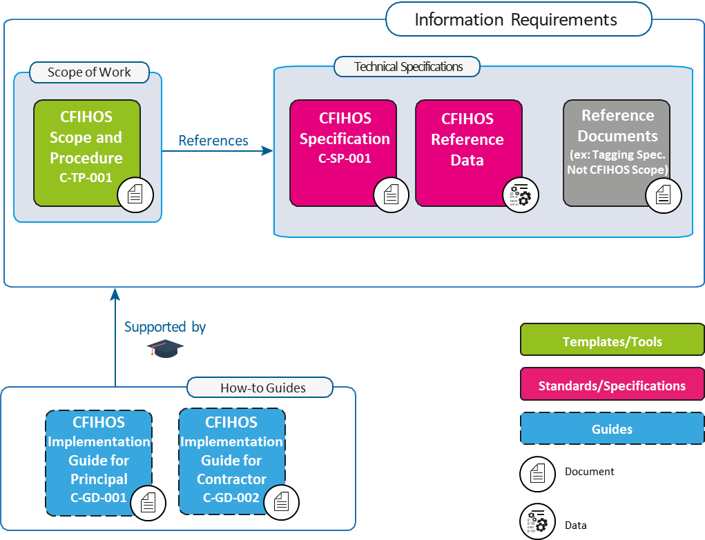

Figure 1: CFIHOS Document Structure
图1 CFIHOS文档结构

Normative References 规范性引用文件
- CFIHOS Specification Document [C-SP-001]
- CFIHOS Implementation Guide for Principal [C-GD-001]
- CFIHOS Implementation Guide for Contractor [C-GD-002]
- CFIHOS Reference Data Library [C-ST-001]
- CFIHOS Data Dictionary [C-DM-002].
- CFIHOS规范[C-SP-001]
- CFIHOS委托方实施指南[C-GD-001]
- CFIHOS承包方实施指南[C-GD-002]
- CFIHOS参考数据类库[C-ST-001]
- CFIHOS数据字典[C-DM-002]

Terms and Definitions, Acronyms and Abbreviations 术语、定义、首字母缩略词和缩略语
The terms used in this document are included below.
下列术语用于本文件。
As-Built Information is the information (data and documents) accurately reflecting the physical plant at the time of the plant handover.
竣工信息是在工厂移交时准确反映物理工厂的信息（数据和文档）。
AIM: Asset Information Model - Information reflecting as-built plant (see A.3).
AIM：AIM（资产信息模型）——反映竣工工厂的信息（见A.3）。
BIM: Building Information Modelling (BIM) is a digital representation of physical and functional characteristics of a facility.
BIM：BIM（建筑信息模型）是设施物理和功能特征的数字化表示。
CDE: Common Data Environment (refer to BS1192) is a concept to share, review, publish and maintain the data and the documents. CDE is meant to achieve the ‘Single Source of Truth’ principle, though it may be built physically by using multiple IT environments such as EDMS and multiple databases.
CDE：CDE（公用数据环境）（引用BS1192）是共享、复核、发布和维护数据和文档环境的概念。CDE旨在实现“单一可信源”原则，尽管其在物理上可通过使用多个IT环境（如EDMS和多个数据库）构建。
Capital Facility Information is the information required to build, operate, and maintain the capital facilities, including data and documents. CFIHOS defines such information.
资产密集型设施信息是建造、运维资产密集型设施所需信息，包括数据和文档。CFIHOS定义此类信息。
Contract Information Management Scope of Work: In this part of a contractual document, Principal specifies the terms and conditions for information delivery by Contractor. Where it is applicable and feasible, quality benchmarks and criteria to fulfil may be included. For any details there could be either referred to specific specification documents or included in the scope of work.
合同信息管理工作范围：委托方在这部分合同文档中规定承包方交付信息的条款和条件，可在适用且可行的情况下包括满足这些要求的质量基准和准则。细节可能引用具体规范或包含在工作范围内。
Contract Information Specification (CIS): The resulting document when CFIHOS is applied to a particular project describing the explicit set of requirements to be fulfilled. Linked to this document is a Reference Data Library that describes the data characteristics and document types. CFIHOS Specification Document [C-SP-001] is the basis for creating a Contract specific Information Specification.
合同信息规范（CIS）：将CFIHOS应用于特定项目时生成的文档，描述要满足的显式要求集。描述数据特征和文档类型的参考数据类库链接至该文档。CFIHOS规范[C-SP-001]是创建合同特定信息规范的基准。
Contractor is the party that carries out all or part of the design, engineering, procurement, construction, commissioning or management of a project or operation of a facility. The Principal may undertake all or part of the duties of the (EPC) Contractor.
承包方是执行项目或设施运行的全部或部分设计、工程设计、采购、施工、调试或管理的一方。委托方可承担（EPC）承包方的全部或部分职责。
CSV: Comma Separated Values, rows of plain text data values in columns separated by commas.
CSV：逗号分隔值，以逗号分隔的列中的纯文本数据值行。
Data is the raw material of information.
数据是信息的原始材料。
Data Governance is a concept and a set of activities that oversees the data/information management or document management carried out to satisfy the requirements of CFIHOS.
数据治理是对为满足CFIHOS要求而执行的数据/信息管理或文档管理进行监管的概念和系列活动。
Data Management is a concept and a set of activities to manage data, information, and documents, including but not limited to the knowledge areas of data architecture, data security, metadata, data quality, data integration, master and reference data, document control, and data handling ethics.
数据管理是管理数据、信息和文档的概念和系列活动，包括但不限于数据架构、数据安全、元数据、数据质量、数据集成、主数据和参考数据、文控和数据处理伦理等知识领域。
Data Model is the visualized data structures, following the notations such as IDEF-1X or IE. Data Models include part of Metadata.
数据模型是可视化的数据结构，遵循IDEF-1X或IE等表示法。数据模型包括部分元数据。
Data Owner is a person responsible for the data quality and belongs to an organization which produces or obtains the data.
数据所有者是对数据质量负责的人，属于生成或获得数据的组织。
Data Steward is a guardian responsible for review and monitor the data quality issues and works closely with Data Owners and IM organization.
数据管理者是负责复核和监测数据质量问题的监护人，并与数据所有者和IM组织密切合作。
Document is in a general sense, a container of data and information, typically includes engineering deliverables and drawings, purchase orders, inspection records and so on.
文档在一般意义上是数据和信息的容器，通常包括工程交付物和图纸、订单、检验记录等。
Document Issue Purposes indicate the purposes of document issues, such as for information, for review and comments or for approval.
文档发布目的指明文档发布的目的，如供参考、供复核及批注或供批准。
DCS: Distributed Control System is a computerised control system for a plant, where autonomous controllers are distributed throughout the system, but with central operator supervisory control.
DCS：DCS（集散控制系统）是一种工厂计算机控制系统，其中自主控制器分布在整个系统中，但有中央操作员监控。
EDMS: Electronic Document Management System is a software programs used to track, manage and store electronic documents.
EDMS：EDMS（电子文档管理系统）是一种用于跟踪、管理和存储电子文档的软件程序。
EPC: Engineering, Procurement, and Construction (EPC) is a form of contracting arrangement used in capital facility industries where the EPC Contractor is responsible for all the activities from design, procurement, construction, commissioning and handover of the project to Principal.
EPC：EPC（设计、采购与施工）是在资产密集型设施行业中使用的一种合同安排形式，其中EPC承包方负责从项目的设计、采购、施工、调试到移交给委托方的所有活动。
Equipment is a physical device designed to perform certain functions.
设备是为执行某些功能而设计的物理装置。
FTP: File Transfer Protocol (FTP) is a standard network protocol used for the transfer of computer files between a client and server across a computer network.
FTP：FTP（文件传输协议）是一种标准的网络协议，用于通过计算机网络在客户端和服务器之间传输计算机文件。
Graphical Data is data intended to show graphical or geometric information such as location, elevation, size, height, and used for CAD (Computer Aided Design).
图形数据是旨在显示位置、标高、尺寸、高度等图形或几何信息的数据，用于CAD（计算机辅助设计）。
Information is Data in context.
信息是语境中的数据。
Information Consumer is a party who defines, receives, and consumes information.
信息使用方是定义、接收和使用信息的一方。
Information Life Cycle is the life cycle of various pieces of information which is defined, designed, created, used, handed over, and eventually disposed of.
信息生命周期是指各种信息的定义、设计、创建、使用、移交和最终处置的生命周期。
Information Management (IM) is the management of data, information and documents to satisfy the CFIHOS requirements and the Contractor’s own information needs. In CFIHOS, Information Management and Data Management are used interchangeably.
IM（信息管理）是对数据、信息和文档的管理，以满足CFIHOS要求和承包方自身的信息需要。CFIHOS中互换使用“信息管理”和“数据管理”。
Information Supplier is a party who supplies information according to the requirements defined by Information Consumer,
信息提供方是指按信息使用方要求提供信息的一方。
Information Supply Chain is the chain of information supplied and consumed between Information Suppliers and Information Consumers.
信息供应链是信息提供方和信息使用方之间的信息提供和使用链。
IT: Information Technology (IT) is the use of computers to store, retrieve, transmit, and manipulate data or information.
IT：IT（信息技术）用计算机来存储、检索、传送和操作数据或信息。
ITB: Information To Bid (sometimes called ITT - Information To Tender) is an invitation to prospective contractors or suppliers to submit a bid, in the form of a packaged document describing contract conditions and specifications.
ITB：ITB（投标邀请）（有时称为ITT（招标邀请））以描述合同条件和规范的文档包形式对潜在承包方或供应方的投标邀请。
Master Document Register (MDR) is a single complete list of documents that contains document metadata which is shared among the relevant parties.
MDR（主文档清册）是单一完整的文档列表，其中包含在相关各方间共享的文档元数据。
Master Tag Register (MTR) is a single complete list of the tags used for the facility, which is shared among the relevant parties.
MTR（主位号清册）是一个在相关各方间共享的单一完整的设施所用位号列表。
Non-graphical Data is data conveyed using alphanumeric characters (as defined by PAS 1192-2:2013). In CFIHOS, Non-graphical Data means all the data except the Graphical Data (see above).
非图形数据是使用字母数字字符（定义见PAS 1192-2:2013）传达的数据。在CFIHOS中，非图形数据是指图形数据（见上文）之外的所有数据。
Owner/Operator or Principal is a party who initiates the project, owns and operates a plant, and ultimately pays for it. Owner/Operator may also include an agent or consultant authorised to act for, and on behalf of, Owner/Operator.
业主/运行方或委托方是发起项目、拥有和运行工厂并最终为其出资的一方。业主/运行方还可包括被授权代表业主/运行方行事的某代理方或顾问方。
Packaged Equipment is equipment composed of multiple sub-components such as s compressor, a gas turbine, etc., typically engineered by specialty equipment Suppliers/Manufacturers.
成套设备是由多个子部件组成的设备，如压缩机、燃气轮机等。成套设备通常由专业设备供应方/制造方设计。
PDF: Portable Document Format (PDF) is a file format developed by Adobe to present documents, including text formatting and images, in a manner independent of application software, hardware, and operating systems.
PDF：PDF（可移植文档格式）是Adobe开发的一种文件格式，用于以独立于应用软件、硬件和操作系统的方式呈现包括文本格式和图像的文档。
PIM: Project Information Model - information still work in progress and subject to change (see A.2).
PIM：PIM（项目信息模型）——信息仍处于工作进展中并可能变更（见A.2）。
RDL: Reference Data Library of the metadata of Data and Documents described in CFIHOS Specification Document [C-SP-001]
RDL：CFIHOS规范[C-SP-001]所述数据和文档的元数据的参考数据类库；
Subcontractor is a company or person who is hired by Contractor to perform a specific task as part of the overall project.
分包方是指承包方雇佣的公司或个人，以执行整个项目中的部分特定任务。
Supplier/Manufacturer: Refer to CFIHOS Specification Document [C-SP-001]
供应方/制造方：参考CFIHOS规范[C-SP-001]。
Tag is a decomposition of a “high-level” Process Unit function into more granular “subfunction”.
位号是“高阶”工艺单元功能至更细颗粒度“子功能”的分解。
Web API is application programming interfaces implemented in web server;
Web API是在Web服务器上实现的应用编程接口；
WORK: Works specified in the Contract Scope of Work.
工作：合同工作范围中规定的工作。
Work Packaging (WP) is a subset of a project that can be assigned to a specific part for execution.
WP（工作包）是能分派给特定方供执行的项目子集。

Information Management Standards 信息管理标准

General 总则
During its performance of the WORK, Contractor shall comply with the following requirements, standards, and any other specific Principal’s instructions associated with the WORK.
在执行工作期间，承包方应遵守以下要求、标准以及与工作有关的任何其他特定委托方指示。

Applicable Regulations and Standards 适用法规和标准
Unless defined otherwise in the contract, the order of precedence for requirements and standards shall be:
- Regulatory requirements
- Contract Information Management Scope of Work and the related CFIHOS Information Specification, including pre-award correspondence, clarifications and notes of pre-selection, and pre-award meetings, which have been incorporated into the Contract
- National standards
- Regional standards
- International standards.
除非合同中另有定义，要求和标准的优先顺序应为：
- 法规要求
- 合同信息管理工作范围和相关CFIHOS信息规范，包括已纳入合同的合同授予前通信、定标前澄清和说明以及合同授予前会议
- 国家标准
- 地区标准
- 国际标准

Project Reference Documents 项目参考文档
Contractor shall follow relevant project reference documents including but not limited to:
- Tag Numbering Specification
- Document Numbering Specification
- Correspondence Management Procedure
- Technical Queries Management Procedure.
承包方应遵循相关的项目参考文档，包括但不限于：
- 位号编码规范
- 文档编码规范
- 通信管理程序
- 技术问询管理程序

General Concepts and Principles 一般概念和原则

General 总则
There are general principles and requirements when Information Management is executed. It is important that Contractor and Suppliers/Manufacturers understand the general concepts and principles described in this section so that the parties involved in the CFIHOS framework have efficient communication based on the common vocabularies and definitions.
实施信息管理有一般原则和要求。重要的是，承包方和供应方/制造方应理解本章所述一般概念和原则，以便CFIHOS框架中涉及的各方基于公用词汇和定义进行高效沟通。

Maturity of Information 信息成熟度
The information related to Capital Facilities is categorised in Table 1 (see also A.1 BIM) and the information under the CFIHOS scope is shown in the cells. Though Graphical data is currently out of CFIHOS scope, Principal may request Contractor to submit data or documents extracted from engineering tools which handle graphical data. Such data and documents shall be regarded as those within CFIHOS scope.
与资产密集型设施相关的信息分类见表1（另见A.1 BIM），CFIHOS范围内的信息见单元格。尽管图形数据目前不在CFIHOS的范围内，但委托方可要求承包方提交从处理图形数据的工程工具中提取的数据或文档。应将这些数据和文档视为在CFIHOS范围内。
Table 1: Maturity of Information and CFIHOS
表1 信息和CFIHOS的成熟度
 | Document 文档 | Non-Graphical Data 非图形数据 | Graphical Data 图形数据
Project Information Model 项目信息模型 | CFIHOS* | CFIHOS* | Currently Out of Scope 目前不在范围内
Asset Information Model 资产信息模型 | CFIHOS | CFIHOS | Currently Out of Scope 目前不在范围内
*Only those required in the Contract
*仅限合同中要求
While Principal ultimately requires an Asset Information Model (As-Build Information), Contractor sometimes carries out concurrent engineering, procurement, and construction work so that information produced in the engineering phase may be altered in subsequent phases where Project Information is produced. Principal can instruct Contractor to submit such information so that Principal can start the process of the Information Management during the EPC phase.
虽然委托方最终需要一个资产信息模型（竣工信息），但承包方有时会并发进行设计、采购和施工工作，这样在工程设计阶段生成的信息可在后续生成项目信息的阶段被更改。委托方能指示承包方提交此类信息，以便委托方能在EPC阶段启动信息管理流程。
The Project Information Model may also include information which is only required for EPC work such as resources utilised to build the plant, temporary facilities and machineries, and the progress of work, which are currently out of the CFIHOS scope.
项目信息模型还可包括仅EPC工作所需信息，如用于目前不在CFIHOS范围内的建造工厂的资源、临时设施和机械以及工作进度。

Information Life Cycle 信息生命周期
Like any asset, Information has its own life cycle. To produce, exchange, and maintain high-quality information, the whole life cycle should be managed starting from the information requirements definition through design and implementation, human operations, storage and maintenance, audit and governance and hand over. The information is eventually disposed of when it is no longer required. The management of this life cycle is an essential part of Information Management.
与任何资产一样，信息也有自己的生命周期。为了生成、交换和维护高质量的信息，宜从信息要求定义开始，经设计和实施、人工操作、存储和维护、审核和治理以及移交，对整个生命周期进行管理。不再需要的信息最终会被处置。生命周期管理是信息管理的必要组成部分。
CFIHOS plays the central role in Information Supply Chain because it defines Information Consumer’s needs, which are ultimately the Principal’s information requirements, with the expectations that such information is delivered by Information Suppliers.
CFIHOS在信息供应链中起着核心作用，因为CFIHOS定义信息使用方的需要，也即最终是委托方的信息要求，并期望信息提供方交付这些信息。
The information produced or collected by one party may be handed over to other parties (external organizations or internal organizations) to be processed, used, and subsequently handed over to yet other parties. This creates the Information Supply Chain.
一方生成或采集的信息可移交给其他方（外部或内部组织）处理、使用，然后移交给另外的其他方，从而形成信息供应链。
The Information Life Cycle and the Information Supply Chain are closely related in terms of:
- Who defines the information requirements
- When and how the requirements are defined and handed over to Information Supplier
- Where and by whom the information is created, processed and maintained
- When and how the information is handed over from who to who
- Who is involved in information quality assurance and where, when, and how it is conducted.
信息生命周期和信息供应链在以下方面密切相关：
- 谁定义信息要求；
- 何时以及如何定义要求并提供给信息提供方；
- 在何处以及由谁创建、处理和维护信息；
- 何时以及如何将信息从谁移交给谁；
- 谁涉及信息质量保证以及在何处、何时和如何进行信息质量保证。
The life cycle processes are shown in Figure 2 and Table 2.
生命周期过程见图2和表2。

Information Suppliers and Information Consumers 信息提供方和信息使用方
When information is handed over from one party to another, the party who supplies the information is called Information Supplier and the party who receives the information is called Information Consumer.
当信息从一方移交给另一方时，提供信息的一方称为信息提供方，接收信息的一方称为信息使用方。
In EPC Contracts, the Principal is Information Consumer and the Contractor is Information Supplier.
在EPC合同中，委托方是信息使用方，承包方是信息提供方。
When a Contractor requests data from its Subcontractors and/or Suppliers/Manufacturer, Contractor becomes Information Consumer, and the Subcontractors and the Suppliers/Manufacturers are Information Suppliers.
当承包方要求其分包方和/或供应方/制造方提供数据时，承包方成为信息使用方，分包方和供应方/制造方是信息提供方。
It is important to note that, unlike other physical assets, Information is a type of asset which does not deteriorate even if it is used. For example, the information that Information Suppliers produce can be used by parties other than the intended Information Consumer. CFIHOS however focuses on the data usage by Principal who specify the data and document requirements, not by other parties.
重要的是要注意信息与其他物理资产不同，是一类即使使用也不会劣化的资产。例如，信息提供方生成的信息能供预期信息使用方以外的其他各方使用，但CFIHOS关注的是规定数据和文档要求的委托方的数据使用，而不是其他各方的数据使用。
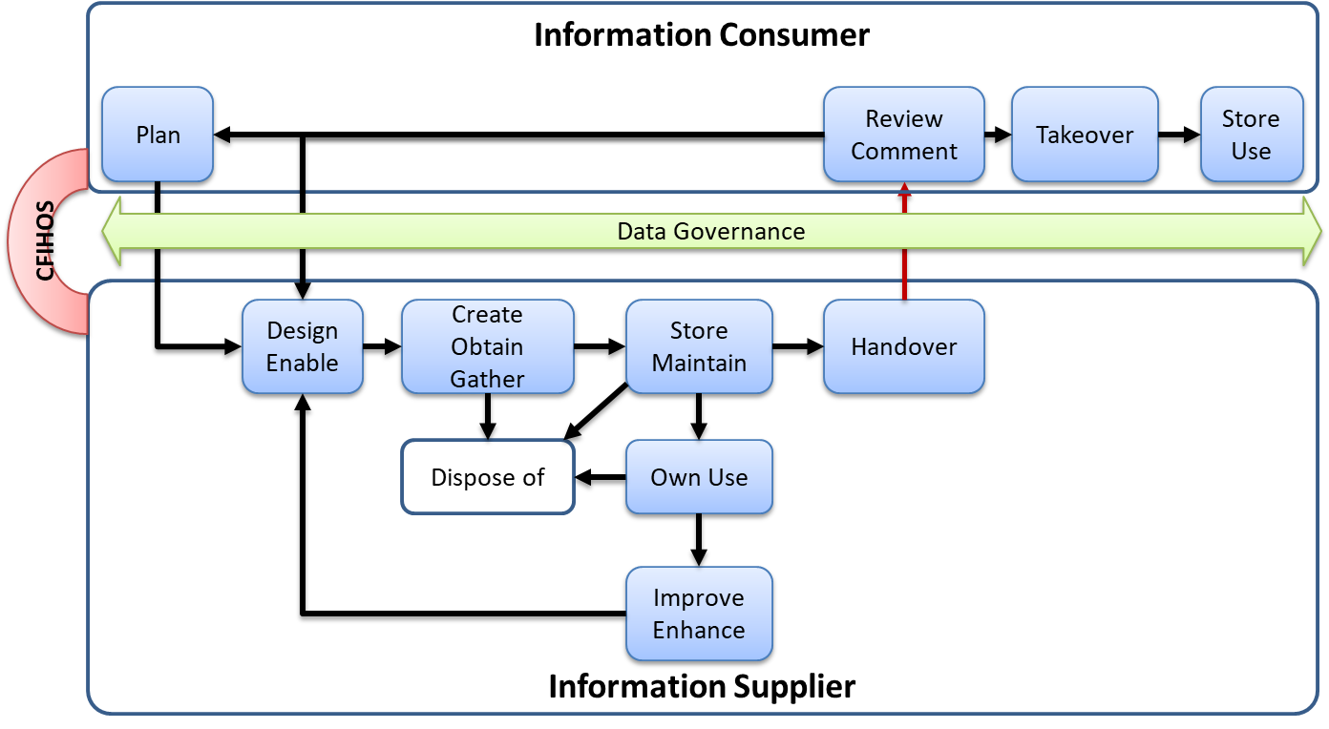
Figure 2: Information Life Cycle with Information Supplier and Information Consumer
图2 涉及信息提供方和信息使用方的信息生命周期
Table 2: Information Life Cycle Process
表2 信息生命周期过程
Life Cycle Process 生命周期过程 | Responsible Party 责任方 | Process Description 过程描述
Plan (Requirements)计划（要求） | Information Consumer 信息使用方 | Defines and provides requirements to Information Supplier  定义要求并向信息提供方提出要求。
Design and Enable设计及使能 | Information Supplier 信息提供方 | Design the process to fulfil the requirements. This process is typically explained in the Information Supplier’s documents such as IM Plan and Procedures.  设计流程以满足要求。通常信息提供方文档（如IM计划和程序）解释该流程。
Create, Obtain or Gather 创建、获得或收集 | Information Supplier 信息提供方 | Actually creates information or obtains/gathers information from other parties.  实际创建信息或从其他方获得/收集信息。
Store and Maintain存储及维护 | Information Supplier 信息提供方 | The information created, obtained or gathered is stored and maintained in CDE.  在CDE中存储并维护已创建、获得或采集的信息。
Hand Over 移交 | Information Supplier 信息提供方 | The information requested by Information Consumer is handed over to the Information Consumer.  向信息使用方移交其要求的信息。
Own Use 自用 | Information Supplier 信息提供方 | The information stored and maintained by Information Supplier may be used for its own purposes or used and processed to produce the Information required by Information Consumer.  信息提供方存储和维护的信息可用于其自身目的，或用于生成信息使用方要求的信息。
Improve and Enhance 改进及提升 | Information Supplier 信息提供方 | The quality of the information which Information Supplier stored and maintained may have to be improved by reviews and assessment of the related processes.  可通过对相关流程的复核与评定改进信息提供方存储和维护的信息的质量。
Hand Over 移交 | Information Supplier 信息提供方 | The information created, obtained, and gathered is handed over to Information Consumer  将创建、获得和收集的信息移交给信息使用方。
Review and Comment 复核及批注 | Information Consumer 信息使用方 | The information handed over to Information Consumer is reviewed against the information requirements in the CIS. If the information does not meet the requirements, Information Consumer provides comments to Information Supplier for improvements.  依据CIS中的信息要求复核移交给信息使用方的信息。如果信息不符合要求，信息使用方向信息提供方提出意见以供改进。  Note: The deficiency of the Information can be caused by the deficiency in the Information requirements specified by Information Consumer, in which case Information Consumer should improve the requirements (Plan process)  注：信息使用方规定的信息要求不足能导致信息不足，这种情况下信息使用方宜改进要求（计划过程）。
Takeover 接管 | Information Consumer 信息使用方 | After the information passes the review process and is accepted, it is taken over by Information Consumer.  信息通过复核过程并被接受后，信息使用方接管该信息。
Store and Use 存储及使用 | Information Consumer 信息使用方 | The information is stored in Information Consumer’s CDE and used for its purposes.  信息存储在信息使用方的CDE中并用于其目的。
Dispose of 处置 | Information Supplier信息提供方 | The information stored and maintained by Information Supplier may become obsolete or useless if it is overridden or found defective, in which case Information Supplier may dispose of the information.  信息提供方存储和维护的信息如果被覆盖或发现有缺陷可作废或无效。在此情况下，信息提供方可处置该信息。

Information Supply Chain Requirements and CFIHOS 信息供应链要求和CFIHOS
Within the Information Supply Chain, Information Consumers and Information Suppliers have a binding contract, following the CFIHOS framework (CFIHOS compliance contract or CFIHOS equivalent contract*). The data and documents are handed over through the Information Supply Chains based on such contracts. In many cases, one party plays both roles when that party receives information from other parties and hands the information over to yet another party (see Figure 3).
在信息供应链中，信息使用方和信息提供方遵循CFIHOS框架（CFIHOS合规合同或CFIHOS等效合同*）签订有约束力的合同。数据和文档通过基于此类合同的信息供应链进行移交。许多情况下，当某一方从其他方接收信息并将信息移交给另一方时，该方同时扮演信息使用方和信息提供方这两种角色（见图3）。
The whole Information Life Cycle process shall be managed and audited with data/information governance activities to ensure the Principal’s Information Requirements are fulfilled. When information quality is found unsatisfactory at the time of the information hand over, recovery and rectification will be required by re-definition, re-design, re-work, and re-submission of the information. All stakeholders including Principal, Contractor, Subcontractors, and Suppliers/ Manufacturers shall be aware of the Information Life Cycle and Information Supply Chain concepts to ensure proactive approach at delivering quality information within allocated project resource hours, cost, and schedule.
应通过数据/信息治理活动管理和审核整个信息生命周期过程，以确保满足委托方的信息要求。如果信息移交时不满意信息质量，则需要通过重新定义、重新设计、重新加工和重新提交信息来进行恢复和整改。所有利益相关方，包括委托方、承包方、分包方和供应方/制造方，都应了解信息生命周期和信息供应链的概念，以确保在分配的项目资源时间、成本和进度内主动提供经过了质量检查的信息。
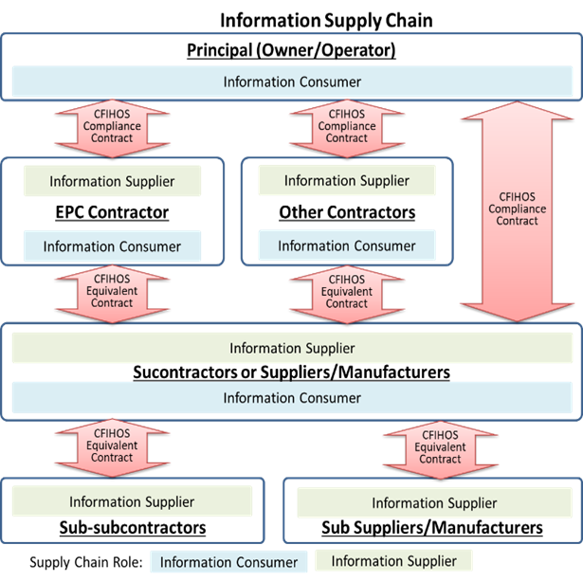

Figure 3: Information Supply Chain
图3 信息供应链
* The difference between CFIHOS compliant contracts and CFIHOS equivalent contracts: While Principal and Contractor have a CFIHOS compliance contract (CIS) following “Implementation Guide for Principal (C-GD-001)”, in subcontracts, Contractor may modify the CIS requirements to suit the Contractor’s needs or with consideration to the capabilities of Suppliers/Manufacturers or Subcontractors, in which case CFIHOS equivalent contracts are used.
* CFIHOS合规合同和CFIHOS等效合同之间的区别：委托方和承包方之间在遵守“委托方实施指南（C-GD-001）”的情况下有CFIHOS合规合同（CIS）；承包方在分包合同中可修改CIS要求，以适应承包方需要或对供应方/制造方或分包方能力的考量，这种情况下使用CFIHOS等效合同。

Capital Facility Information 资产密集型设施信息

General 总则
Capital Facility Information includes data and documents required for facility operation and maintenance. In this section, the concepts and principles applied to data and document management are discussed respectively. Further guidance on the relationship between data and documents can be found in the CFIHOS Implementation Guides [C-GD-001, C-GD-002].
- Document Metadata: Documents themselves are described, classified, and managed by data as described in Document Management section 6.5.2
- Information Metadata: Metadata to define the information by its definitions, formats, relationships, the value ranges (see CFIHOS Specification Document [C-SP-001])
- Consistency between Data and Documents: Documents contain Data as their contents. For example, Tag numbers exist in documents as well as in data sets. Consistency should be ensured within Documents, among Documents, and between Documents and Data as described in Information Quality Management section 6.3
- Data Transmission: The collection of data can be presented and transmitted as documents – see Annex B.
资产密集型设施信息包括设施运维所需数据和文档。本条将分别讨论应用于数据和文档管理的概念和原则。有关数据和文档之间关系的进一步指导见CFIHOS实施指南[C-GD-001、C-GD-002]。
- 文档元数据：如6.5.2设施文档管理所述，文档本身由数据描述、分类和管理；
- 信息元数据：通过信息的定义、格式、关系和值域定义信息的元数据（见CFIHOS规范[C-SP-001]）；
- 数据和文档之间的一致性：文档包含数据作为其内容。例如，位号编码既存在于文档中，也存在于数据集中。如6.3信息质量管理所述，宜确保文档内部、文档之间、文档与数据之间的一致性；
- 数据传送：采集的数据能作为文档呈现和传送，见附录B。

Capital Facility Documents 资产密集型设施文档

Scope of the Capital Facility Documents 资产密集型设施文档的范围
Capital Facility Documents include but are not limited to the following:
- Project Plans and Procedures
- Engineering deliverables, including those supplied by Supplier/Manufacturers
- Engineering documents
- Engineering drawings
- Procurement related documents
- Construction related documents
- Commissioning related documents
- QA and QC related documents
- Any other documents required by Principal.
资产密集型设施文档包括但不限于以下：
- 项目计划和程序；
- 工程交付物，包括供应方/制造方提供的交付物；
- 设计文档；
- 设计图纸；
- 采购相关文档；
- 施工相关文档；
- 调试相关文档；
- QA（质量保证）和QC（质量控制）相关文档；
- 委托方要求的任何其他文档。
Please refer to the CFIHOS RDL [C-ST-001] for details.
详细内容见CFIHOS RDL [C-ST-001]。

Master Document Register (MDR) 主文档清册（MDR）
Principal and Contractor shall agree to, update, maintain, and share a single MDR containing all the project document deliverables.
委托方和承包方应同意、更新、维护和共享包含所有项目文档交付物的单一MDR。
Please refer to the CFIHOS Specification Document [C-SP-001], CFIHOS RDL [C-ST-001], and the CFIHOS Data Model [C-DM-001] for the detailed structure of the MDR.
MDR详细结构见CFIHOS规范[C-SP-001]、CFIHOS RDL[C-ST-001]和CFIHOS数据模型[C-DM-001]。
Contractor shall:
- Issue the first version of MDR to Principal for review and approval by Principal within thirty (30) days of the contract commencement date unless otherwise specified in CIS
- Maintain and issue the revised MDR to Principal whenever the MDR is updated
- Issue and transmit documents in accordance with the latest MDR by following the Document Number, Document Title, and Revision Number in the MDR.
承包方应：
- 除非CIS另有规定，否则应在合同生效日期后的三十（30）天内向委托方发布第一版MDR，供委托方复核和批准；
- 每当更新MDR后，都要维护修订的MDR并向委托方发布；
- 按最新的MDR，遵循MDR中的文档编码、文档标题和版本号发布和传送文档。

Document Properties (Metadata) 文档特性（元数据）
All Documents shall be accompanied by their Document metadata as described in CFIHOS Specification Document [C-SP-001].
如CFIHOS规范[C-SP-001]所述，所有文档应随附其文档元数据。

Document Index 文档索引
When multiple files constitute one document (e.g., multiple renditions) the transmittal shall contain a document index file.
当多个文件构成一份文档（例如多个呈现副本）时，传送单应包含一个文档索引文件。

Document Templates 文档模板
The Document template for each category of document type shall be proposed by Contractor and shall be approved by Principal at the beginning of the Project. Contractor shall use the approved document templates including but not limited to
- Engineering Documents (Philosophies, Procedures, Specifications)
- Engineering Drawings
- Engineering Data Sheets
- Correspondences
- Meeting Minutes
- Change Orders
应由承包方建议各类文档类型的文档模板，并应在项目开始时由委托方批准。承包方应使用批准的文档模板，包括但不限于：
- 工程文档（方法、程序、规范）
- 工程图纸
- 工程数据表
- 通信
- 会议纪要
- 变更单

Document Specific Requirements 文档具体要求
Encryption and Password Requirements
Principal shall state within the security requirements if the documents shall or shall not be encrypted with passwords when submitted. If they are encrypted with passwords, Principal and Contractor shall agree on how to handle the passwords.
加密和密码要求
委托方应在安全要求中明示提交文档时应否使用密码加密。如果使用密码加密，委托方和承包方应就如何管理密码达成一致。
File Compression and Packaging Requirements
Principal shall state if the document(s) whether a single file or multiple files shall be compressed and packaged (namely “zipped”) or not as well as their electronic package file naming conventions.
文件压缩和打包要求
委托方应明示文档是否应压缩和打包（即“压缩”）为单一文件或多个文件，及电子包文件命名规范。
Archiving Requirements
For document archive requirements, Contractor shall follow the specifications provided in CFIHOS Specification Document [C-SP-001].
存档要求
对于文档存档要求，承包方应遵循CFIHOS规范[C-SP-001]中提供的规范。

Information Relationship Requirements 信息关系要求
The information relationships requirements such as Tag to Document, Tag to Tag, Document to Document, Document to Equipment, and Document to Area are specified in CIS and Contractor shall include the implementation plan to achieve such requirements in Contractor’s Information Management Plan (see 6.2).
CIS中规定位号至文档、位号至位号、文档至文档、文档至设备和文档至区域等信息关系要求，承包方应在其信息管理计划中包含实现这些要求的实施计划（见6.2）。
Principal shall state which relationships and which information types are subject to these requirements.
委托方应明示哪些关系和哪些信息类型要服从这些要求。

Capital Facility Data 资产密集型设施数据

Tags and Equipment 位号和设备
Tag represents a specific function in a Plant with its logical location identified by a Tag number. Therefore, the properties of Tag are function related. Equipment represents a physical asset to satisfy a certain function represented by Tag. Therefore, the properties of Equipment are asset related properties such as a serial number and a manufacturer and actual purchase date.
位号表示工厂中的某个特定功能，位号编码标识其逻辑位置，因此位号的特性与功能相关。设备表示某个物理资产，以满足位号所代表的某个确定功能。因此设备特性是与资产相关的特性，如序列号、制造方和实际购买日期。
Types of Tags can be categorized into the following:
- Tags without equipment – sometimes called as soft tags, such as DCS tags
- Tags attached with equipment – sometimes called as hard tags.
位号类型能分为以下：
- 不带设备的位号——有时称为软位号，如DCS位号；
- 带设备的位号——有时称为硬位号。
It is important for Principal and Contractor to recognize the one-to-many relationships between Tag (one) and Equipment (many) to express scenarios such as:
- Multiple pieces of equipment can be installed to one Tag over time in the commissioning phase or the maintenance period (for example, switched or replaced with another piece of equipment). We note in such case, only a piece of Equipment is installed to a Tag at one particular point in time
- Multiple pieces of Equipment can be installed to a Tag at the same time. Principal shall specify if this scenario is allowed in the EPC phase to keep the referential integrity.
对于委托方和承包方而言，重要的是要认识到位号（一个）和设备（多个）之间的一对多关系，以表达如下场景：
- 在调试阶段或维护期，能随时间将多台设备安装至同一位号（例如，切换或替换为另一台设备）。注意在这种情况下，在某个特定时间点，只有一台设备安装至同一位号；
- 多台设备能同时安装在同一位号上。委托方应规定在EPC阶段是否容许这种情况，以保持引用完整性。
Except in the latter case above, the Tag and Equipment relationship should be one-to-one at one time.
除上述后一种情况外，同一时间位号和设备的关系宜为一对一关系。
Principal and Contractor shall note that there are engineering tools not capable of representing the relationship between Tag and Equipment and only treating Tag and Equipment as a single entity.
委托方和承包方应注意，有些工程工具不能表示位号和设备之间的关系，只能将位号和设备视为单一实体。

Capital Facility Data Entities 资产密集型设施数据实体
Capital Facility Data is composed of the following - see CFIHOS Specification Document [C-SP-001] for more details
- Geographical Surface (Site and Area)
- Function (Plant - Process Unit - Tag)
- Plant Breakdown Structure
- Commissioning Unit - Commissioning System – Tag
- Maintenance Unit - Maintenance System - Tag and Equipment
- Construction Assembly – Tag
- Process Unit – Equipment
- Tag Physical Connection
- Corrosion (Corrosion Loop Type – Corrosion Loop)
- Master Data (Company, Purchase Order, Property, and Property Pick List).
资产密集型设施数据由以下组成——更多详细信息见CFIHOS规范[C-SP-001]。
- 地理表面（地点和区域）
- 功能（工厂 - 工艺单元 - 位号）
- 工厂分解结构
- 调试单元 - 调试系统 - 位号
- 维护单元 - 维护系统 - 位号和设备
- 施工组装 - 位号
- 工艺单元 - 设备
- 位号物理连接
- 腐蚀（腐蚀回路类型 - 腐蚀回路）
- 主数据（公司、订单、特性和特性值列表）

Class and Properties Definitions for Tags and Equipment (Information Metadata) 位号和设备的类和特性定义（信息元数据）
Correct understanding of the data structure among Tag Class, Tag, and Tag Properties, and Equipment Class, Equipment, and Equipment Properties is essential to Capital Facility Data.
- Tag is a decomposition of a “high-level” Process Unit function into more granular “sub function”. Each Tag Class has its own set of properties. A Tag always belongs to a Tag Class. Therefore, a Tag has its own set of property values for the Tag Class properties. For example, “Pump” is a Tag Class and has designated properties such as “Maximum Design Pressure” and “Operating Pressure”. If a Tag “P-001” belongs to the “Pump” (Tag Class), then this Tag shall have property values for “Maximum Design Pressure” and “Operating Pressure”
- Equipment is a physical device designed to perform a function. Each Equipment Class has its own set of properties. A piece of Equipment always belongs to an Equipment Class. Therefore, a piece of Equipment has its own set of property values for the Equipment Class properties. For example, “Centrifugal Pump” is an Equipment Class and has designated properties such as “Weight” and “Size”. If a piece of Equipment belongs to the “Centrifugal Pump” (Equipment Class), then this Equipment shall have property values for “Weight” and “Size”.
正确理解位号类、位号和位号特性以及设备类、设备和设备特性之间的数据结构对于资产密集型设施数据至关重要。
- 位号是将“高阶”工艺单元功能分解为更细化的“子功能”。每个位号类都有自己的特性集。一个位号总是属于某位号类。因此，一个位号有其所属位号类特性的值集。例如，“泵”是一个位号类，具有如“最大设计压力”和“工作压力”特性。如果位号“P-001”属于“泵”（位号类），则该位号应有“最大设计压力”和“工作压力”的特性值；
- 设备是设计用于执行功能的物理设备。每个设备类都有自己的特性集。一台设备总是属于某设备类。因此，一台设备有其所属设备类特性的值集。例如，“离心泵”是一个设备类，具有如“重量”和“尺寸”特性。如果一件设备属于“离心泵”（设备类），则该设备应有“重量”和“尺寸”的特性值。

Master Tag Register (MTR) 主位号清册（MTR）
MTR is the complete list of all the Tags whose information shall be handed over to Principal. MTR plays a central role in Facility Data Management and shall be delivered as structured data in accordance to CFIHOS Data Dictionary [C-DM-002].
MTR是所有位号的完整列表，其信息应移交给委托方。MTR是设施数据管理的核心，应按CFIHOS数据字典[C-DM-002]以结构化数据交付。

Data Templates and Data Files 数据模板和数据文件
Information Consumer shall specify data templates (typically in CSV or Excel sheet formats) for Information Supplier to fill the Data in. Information Supplier shall follow the templates for the Data submission to Information Consumer. The Data packaged into Data Files are treated as Documents with designated Document Numbers, Revision Numbers, and Issue Purposes.
信息使用方应为信息提供方规定数据模板（通常为CSV或Excel工作表格式）以填写数据。信息提供方应遵循模板将数据提交给信息使用方。打包为数据文件的数据被视为有文档编码、版本号和发布目的的文档。

Data Submission, Review and Revision 数据提交、复核和修订
Data deliverables prepared as structured data, shall be submitted, reviewed with comments and revised following similar protocols used for documents. Therefore, the data templates used to collect and submit Data deliverables shall be treated as documents. Information Consumer and Information Supplier shall follow the general concepts and principles described in section 4.4.2 when Data is exchanged.
对于以结构化数据准备的数据交付物，应遵循与用于文档的类似的规约进行提交、复核及批注和修订。因此，用于采集和提交数据交付物的数据模板应视为文档。信息使用方和信息提供方在交换数据时应遵循5.4.2所述通用概念和原则。
Information Supplier shall transfer CFIHOS data by:
- Establishing a document numbering rule for the CFIHOS Data Submission in the Document numbering procedure. This document numbering shall be used for all the CFIHOS data submissions transmitted by Information Supplier. The document shall be titled "Project Name CFIHOS Data Submission"
- Allocating a number and the new revision code for the document
- If so required in the Contract, creating a zip file to hold all the files part of the “Project Name CFIHOS Data Submission”. These files shall be formatted according to CFIHOS Specification. The set of files provided shall demonstrate the full referential integrity.
信息提供方应通过以下方式传输CFIHOS数据：
- 在文档编码程序中建立CFIHOS数据递件的文档编码程序。应将此文档编码应用于信息提供方传送的所有CFIHOS数据递件。文档标题应为“项目名称CFIHOS数据递件”；
- 为文档分配编码和新的版本号；
- 如果合同中有要求，则创建一个压缩文件来保存“项目名称CFIHOS数据递件”中的所有文件。这些文件的格式应遵守CFIHOS规范。应证实所提供文件集具备完全的引用完整性。
All data handed over by Information Supplier, whether intermediate or final, shall be included in a formal transmittal. Prior to submitting the formal transmittal, Information Supplier shall ensure;
- The information is numbered correctly and signed off to the appropriate level of authority
- The correct template has been used
- The information is structured in accordance with the Contract Information Management Scope of Work and the related specifications.
信息提供方移交的所有数据都应包含在正式传送单中，无论是中间数据还是最终数据。在提交正式传送单之前，信息提供方应确保：
- 信息编码正确，并由适当级别的机构签发；
- 使用了正确的模板；
- 信息结构遵守合同信息管理工作范围和相关规范。

Information Security 信息安全
Information Security refers to the protection of information in its broadest sense and covers access to information, protection of information against intrusion and damage and the procedures necessary to maintain the integrity of information.
信息安全是指最广泛意义上的信息保护，包括信息的访问、信息的防侵入和防破坏以及维护信息完整性所必需的程序。
Information Supplier shall ensure compliance with the Information Consumer’s Information Security requirements and ensure processes and procedures are in place to safeguard business continuity and minimize business damage.
信息提供方应确保遵守信息使用方的信息安全要求，并确保有适当的流程和程序来保障业务连续性并最小化业务损失。
A focus should be placed on ensuring:
- Confidentiality, protecting sensitive information from unauthorized disclosure
- Integrity, safeguarding the accuracy and completeness of information
- Availability, ensuring the project information and associated are available to users as required.
宜着重确保：
- 保密性，保护敏感信息免于未经授权披露；
- 完整性，保障信息的准确性和完整性；
- 可用性，确保项目信息及其相关项按要求对用户可用。
Information security practices shall be guided by ISO/IEC 27002. In the case of business-critical information, Information Consumer may request that Information Supplier is formally audited and certified according to ISO/IEC 27001. ISO/IEC 27001 requires management to:
- Systematically examine the organization's information security risks, taking account of the threats, vulnerabilities, and impacts
- Design and implement a coherent and comprehensive suite of information security controls and/or other forms of risk treatment (such as risk avoidance, risk mitigation, or risk transfer) to address those risks that are deemed unacceptable
- Adopt an overarching management process to ensure that the information security controls continue to meet the organization's information security needs on an ongoing basis.
信息安全实践应以ISO/IEC 27002为指导。对于关键业务信息，信息使用方可要求信息提供方按ISO/IEC 27001进行正式审核和认证。ISO/IEC 27001要求管理层：
- 考虑威胁、漏洞和影响，系统地审查组织的信息安全风险；
- 设计和实施一套连贯、全面的信息安全控制和/或其他形式的风险处理（如风险规避、风险缓解或风险转移）措施，以应对不可接受的风险；
- 采用总体管理流程，确保信息安全控制持续满足组织的信息安全需要。

Information Management 信息管理

Management of Data, Information, and Documents 数据、信息和文档管理
Information Management is the management of data, information, and documents as well as relationships and consistencies among those. Information requirements described in the CFIHOS Specification Document [C-SP-001] will not simply be achieved by accident. It requires plans, controls, and assurance processes. Information Management is the development, execution, and supervision of plans, policies, programs, and practices that deliver, control, protect, and enhance the value of data and information assets throughout their lifecycles.
信息管理是对数据、信息和文档以及它们之间的关系和一致性的管理。CFIHOS规范[C-SP-001]所述信息要求不会被简单地偶然实现，而是需要通过计划、控制和保证过程。信息管理是对计划、策略、程序和实践的制定、执行和监督，这些计划、策略、程序和实践可在数据和信息资产整个生命周期中交付、控制、保护和提升其价值。
Information management activities are wide-ranging. They include everything from the ability to make consistent decisions about how to get strategic value from data to the technical deployment and performance of databases. Thus, information management requires both technical and non-technical (i.e., ‘business’) skills. Responsibility for managing information must be shared between business and information technology roles, and people in both areas must be able to collaborate to ensure that an organization has high-quality information that meets the CFIHOS requirements.
信息管理活动范围广泛，包括如何从数据中获得战略价值并做出一致决策的能力，到技术部署和数据库性能的所有事项。因此信息管理需要技术和非技术（即“业务”）技能，其责任必须由业务和信息技术角色分担，且这两个领域的人员必须能够协作以确保组织拥有符合CFIHOS要求的高质量信息。

Project Information Management Implementation Plan 项目信息管理实施方案
Contractor shall develop and submit to Principal for approval a Contractor Information Management Implementation Plan to satisfy the requirements described in the CIS. The Plan shall describe the following as a minimum:
- How to identify sources of data and information
- How to create, capture, gather, and validate data and information from various sources
- How to receive and hand over data and information across the Information Supply Chain
- How third-party information will be managed
- Relevant Contractor’s corporate plans and procedures
- The use of an appropriate EDMS and procedure that is integrated with Principal’s other systems and related procedure(s)
- How to monitor and report the data and information quality
- Contractor’s audit process for recording changes to data and information
- The Information Management organization and scope of responsibilities
- How Contractor’s internal tools and processes shall be implemented and utilised, and how these will interface with Principal’s Common Data Environment (CDE).
承包方应制定一份承包方信息管理实施计划以满足CIS所述要求，并提交委托方供批准。该计划至少应描述以下：
- 如何确定数据和信息来源；
- 如何创建、获取、收集和确认来自各种来源的数据和信息；
- 如何在信息供应链中接收和移交数据和信息；
- 如何管理第三方信息；
- 相关承包方的公司计划和程序；
- 使用与委托方其他系统和相关程序集成的适当的EDMS和程序；
- 如何监测和报告数据和信息质量；
- 承包方用于记录数据和信息更改的审核流程；
- 信息管理机构和职责范围；
- 应如何实施和利用承包方内部工具和流程，及如何与委托方CDE（公用数据环境）交互。

Information Quality Management 信息质量管理
Understanding of the impacts brought by poor-quality information, poor planning, siloed systems, inconsistent development processes, incomplete documentation, a lack of standards, or a lack of governance is essential. All disciplines contribute to the quality of data, not just the Information Management Team.
理解劣质信息、不良规划、孤岛系统、不一致的生成流程、不完整的文档、缺乏标准或缺乏治理所带来的影响至关重要。所有专业都会影响数据质量，而不仅仅只是信息管理团队。
Formal information quality management is like continuous quality management of other assets. It includes managing information through its lifecycle by setting standards, building quality into the processes that create, transform, and store information, and measuring the quality against standards including:
- Completeness of information
- Consistencies within Documents, between Documents, among Data, and between Data and Documents (see CFIHOS Specification Document [C-SP-001])
- Correctness and accuracy (refer to ISO 8000, ISO 9000, and ISO 15926-4)
- Information Availability and Delivery Timing (information not available at its required time has no value).
正式的信息质量管理与其他资产的持续质量管理类似，包括通过设置标准，将质量建立在创建、转换和存储信息过程中，及依据标准衡量质量，以在整个信息生命周期中管理信息。这些标准包括：
- 信息的完整性；
- 文档内部、文档之间、数据之间以及数据和文档之间的一致性（见CFIHOS规范[C-SP-001]）；
- 正确性和准确性（参考ISO 8000、ISO 9000和ISO 15926-4）；
- 信息可用性和交付时间（在要求时间不可用的信息是没有价值的）。
To achieve the information quality requirements in the CFIHOS Specification Document [C-SP-001], the following shall be considered:
- Ensure the correct understanding of the metadata, including applicable data models
- Plan and define procedures to produce, store, and maintain quality information, including human operations and IT tools and processes
- Monitor and report information quality using metrics
- Act on improvement measures if necessary
- Audit information quality management by Data/Information Governance.
为了达到CFIHOS规范[C-SP-001]中的信息质量要求，应考虑以下：
- 确保正确理解元数据，包括适用的数据模型；
- 计划和定义生成、存储和维护质量信息的程序，包括人工操作以及IT工具和流程；
- 使用指标监测和报告信息质量；
- 必要时采取改进措施；
- 通过数据/信息治理审核信息质量管理。

Information Security Management 信息安全管理
Information security management as a minimum includes the following:
- Security by design: how to protect information by system, environment, and technology
- Security by information handling process: how to protect information by pre-defined procedures
- Security by human factors: how to protect information by principles and ethics
- Actions to be taken if and when security breaches occur
- Monitor, review, and report information security environment, activities and events.
信息安全管理至少包括以下：
- 设计安全性：如何通过系统、环境和技术保护信息；
- 信息处理过程安全性：如何通过预定义的程序保护信息；
- 人为因素安全性：如何通过原则和伦理保护信息；
- 如发生安全违规时和当发生安全违规时要采取的行动；
- 监测、复核和报告信息安全环境、活动和事件。
Contractor shall propose how to achieve the security requirements described in section 5.5 with consideration of the above.
承包方应考虑以上内容，建议如何达到5.5所述安全要求。

Facility Information Management 设施信息管理

Scope of Facility Information Management 设施信息管理的范围
Facility Information Management includes the following:
- Facility Document Management
- Facility Data Management
- Data and Document Consistency Management.
设施信息管理包括以下：
- 设施文档管理；
- 设施数据管理；
- 数据和文档一致性管理。

Facility Document Management设施文档管理

General总则
Project documents include but are not limited to engineering documents, drawings, specifications, price-less purchase requisitions, orders and order items, inspection records and certificates including the documents from Supplier/Manufacturers and/or Subcontractors.
项目文档包括但不限于工程文档、图纸、规范、不定价请购单、订单和订单项、检验记录和证书（包括来自供应方/制造方和/或分包方的文档）。
The Documents stored in e-files are considered as documents. Depending on the project requirements, hardcopies of documents shall also be managed. The essential components for document management are:
- Document Metadata (see CFIHOS Specification Document [C-SP-001])
- Document Templates and Formats (see CFIHOS Specification Document [C-SP-001])
- Discipline Document Types (see CFIHOS Specification Document [C-SP-001])
- Master Document Register (see section 5.4.2.2 of this document).
以电子文件存储的文档被视为文档。根据项目要求，还应管理文档的硬拷贝。文档管理的必要构成为：
- 文档元数据（见CFIHOS规范[C-SP-001]）；
- 文档模板和格式（见CFIHOS规范[C-SP-001]）；
- 专业文档类型（见CFIHOS规范[C-SP-001]）；
- 主文档清册（见5.4.2.2）。

Document Management Procedure 文档管理程序
Contractor shall, unless otherwise specified in CIS, within thirty (30) days of the contract commencement date, develop and submit the Document Management Procedure. The Document Management Procedure describes how Contractor will manage documents in accordance with the requirements in CIS incorporating Contractor’s internal quality assurance processes.
除非CIS中另有规定，否则承包方应在合同开始之日起三十（30）天内制定并提交文档管理程序。文档管理程序描述承包方将如何按CIS的要求，结合承包方内部质量保证流程来管理文档。
The procedure shall include as a minimum the document numbering specification, document submission, review and approval workflows, MDR management, and supporting EDMS tool in consideration of the following:
- Compliance with the Principal’s document numbering specification
- As-Built Documents that reflect the physical assets handed over to Principal in accordance with CFIHOS Specification Document [C-SP-001] and RDL [C-ST-001]
- Usage of a single EDMS to store and manage all the project documents.
该程序至少应包括文档编码规范，文档提交、复核和批准工作流程，MDR管理及支持EDMS工具，且考虑以下：
- 遵守委托方文档编码规范；
- 反映按CFIHOS规范[C-SP-001]和RDL[C-ST-001]移交给委托方的物理资产的竣工文档；
- 使用单一EDMS来存储和管理所有项目文档。

Document Distribution Matrix 文档分发矩阵
Contractor shall demonstrate appropriate and auditable document distribution mechanisms by means of document distribution matrices. Contractor shall propose, maintain, and submit the matrix to Principal for review and approval.
承包方应通过文档分发矩阵展示适当且可审核的文档分发机制。承包方应提出、维护和提交该矩阵给委托方供复核和批准。

Timing of Document Delivery 文档交付时间
The MDR shall be used to plan, forecast, and track the documents deliveries and statuses. Principal shall state the document turnaround durations for review, comments, and approval or rejection. The Contractor’s submission dates are the dates when Contractor delivers the documents to the Principal’s receiving device accompanied with the appropriate delivery notices issued by Contractor.
MDR应用于计划、预测和跟踪文档的交付和状态。委托方应明示文档供复核、批注以及批准或拒绝的周转期。承包方提交日期是承包方将文档连同承包方发出的适当的交付通知一并交付至委托方接收系统的日期。
The document return dates are the dates when Principal places the documents to the Contractor’s receiving device accompanied with the appropriate delivery notices issued by Principal. In both cases, the document shall be delivered in accordance with the rules specified in the approved Document Management Procedure and each party’s document control team may reject the delivery if the rules are violated.
文档返回日期是委托方将文档连同委托方发出的适当交付通知一并返回至承包方接收系统上的日期。这两种情况下均应按批准的文档管理程序中规定的规则交付文档，如果违反规则则各方的文控团队都可拒收交付件。

Document Issue Purposes and Return Statuses 文档发布目的和返回状态
Capital Facility Documents issued during the EPC phase shall be categorised by the purposes of the document issuance as follows:
- For Information: the documents are issued for information and do not necessarily require review, comment or approval
- For Review and Comment: the documents are issued for review and comment, and Contractor may proceed with the WORK without waiting for the comments by Principal. Contractor shall however revise the documents if Principal so requests
- For Approval: the documents are issued for Principal’s approval, in which case the document return statuses will fall into the following types:
  - Approved: documents have been approved, and Contractor can proceed with the WORK
  - Approved with comments: documents have been approved, and Contractor can proceed with the WORK. However, Contractor shall still revise and resubmit the documents to Principal
  - Rejected: Contractor shall revise and resubmit the documents until they are approved. Contractor shall not proceed with the WORK. Principal shall provide the reasons for the rejection to avoid repeated submissions; Principal’s rejections can occur due to the following reasons:
- Administrative reasons such as deviations from the rules stated in the approved Document Management Procedure, in which case the documents shall be re-submitted following the Procedure
- Quality Issues (any other than the above administrative reasons).
In either case, the reasons for rejection shall be clearly stated when the documents are returned.
在EPC阶段发布的资产密集型设施文档应按发布文档的目的分类如下：
- 供参考：发布文档供参考。不一定需要复核、批注或批准。
- 供复核及批注：发布文档供复核及批注。承包方可不等待委托方意见而继续开展工作。但如果委托方要求，承包方应修订文档。
- 供批准：发布文档供委托方批准。这种情况下文档的返回状态分为以下类型：
  - 已批准：文档已被批准，承包方能继续开展工作；
  - 带意见批准：文档已被批准，承包方能继续开展工作。但是，承包方仍应修订文档并重新提交给委托方；
  - 拒绝：承包方应修订并重新提交文档，直至文档被批准。承包方不应继续开展工作。委托方应提供拒绝的理由，以避免重复提交；能发生委托方拒绝的原因如下：
- 管理原因，如偏离已批准的文档管理程序中明示的规则。这种情况下应遵循该程序重新提交文档；
- 质量问题（除上述管理原因外）。
无论何种情况，返回文档时均应明示拒绝的原因。
The approval of the documents will not relieve Contractor from the responsibilities and/or liabilities under the Contract.
文档获批不会免除承包方在合同下的责任和/或义务。

Contractor’s Revisions and Re-submissions of Documents 承包方修订和重新提交文档
When Contractor incorporates comments provided by Principal and revise the documents, Contractor shall
- Clearly indicate where the comments have been incorporated
- Clearly indicate any part of documents which has been revised
- Allocate the next revision number for re-submission.
承包方采纳委托方提供的意见并修订文档时应：
- 清楚指明意见已在何处采纳；
- 清楚指明文档的任何已修订部分；
- 分配下一个版本号以重新提交。

EDMS Usage Scenarios EDMS使用场景
Principal shall dictate or agree with Contractor on how the EDMS tool is used.
- Single Shared EDMS between Principal and Contractor:
- If Principal agrees to use the Contractor’s EDMS, a single EDMS shall be used facing Principal even though Contractor is a joint-venture or a consortium with multiple Contractors unless otherwise specified in the Contract. Contractor shall provide the access permissions, the user manuals, and conduct the training for Principal.
- Separate EDMS for Principal and Contractor:
- If Principal and Contractor to use their respective EDMS, the document exchange specifications shall be provided and agreed. If the document is exchanged through file upload and download interfaces, the specifications of the Transmittal shall be agreed (see Annex B.3). Contractor shall still use a single EDMS, even in cases where Contractor is a joint-venture or a consortium with multiple contractors, unless otherwise allowed in the Contract.
委托方应指定或与承包方商定如何使用EDMS工具。
- 委托方和承包方共享使用单套EDMS：
- 如果委托方同意使用承包方EDMS，除非合同另有规定，否则即使承包方是合资企业或与多个承包方的联合体，也应面向委托方使用单一EDMS。承包方应提供访问权限、用户手册，并对委托方进行培训。
- 委托方和承包方各自使用单独EDMS：
- 如果委托方和承包方使用各自的EDMS，则应提供并商定文档交换规范。如果文档通过文件上传和下载接口进行交换，应商定传送单规范（见附录B.3）。除非合同容许，否则即使承包方是合资企业或由多个承包方组成的联合体，承包方仍应使用单一EDMS。

Review and Comment feature of EDMS EDMS的复核及批注功能
Principal may choose one of the following scenarios for review and comment.
- Commenting on document hard-copies, scan and upload onto EDMS
- Use of PDF commenting feature and upload onto EDMS
- Multi-user concurrent reviews and comment feature of EDMS.
委托方可选择以下场景之一供复核及批注。
- 批注纸质文档，扫描并上传至EDMS；
- 使用PDF批注功能并上传至EDMS；
- 使用EDMS的多用户并发复核及批注功能。

Facility Data Management 设施数据管理

General 总则
Facility Data becomes part of the vital assets of Principal when the plant is operated and maintained. The data quality and delivery requirements shall be understood by Contractor.
设施数据是工厂运维时委托方的重要资产的一部分。承包方应理解数据质量和交付要求。
Contractor’s approach to implementation, to achieve the requirements, shall be presented, demonstrated, and approved by Principal. Essential components of Facility Data management are:
- Metadata and data structure (see CFIHOS Specification Documents [C-SP-001])
- Data Templates and Formats (see section 5.4.3.5 and CFIHOS Data Dictionary)
- Master Tag Register (see section 6.5.3.4).
承包方为达到要求的实施方法应向委托方展示、证明并经其批准。设施数据管理的必要构成为：
- 元数据和数据结构（见CFIHOS规范[C-SP-001]）；
- 数据模板和格式（见5.4.3.5和CFIHOS数据字典）；
- 主位号清册（见6.5.3.4）。

Data Management Procedure 数据管理程序
Contractor shall, unless otherwise specified in CIS, within thirty (30) days of the contract commencement date, develop and submit the Data Management Procedure which describes Contractor’s understanding of the requirements, how Contractor manages data in accordance with the requirements in CIS, and how Contractor’s internal quality assurance and software tools are implemented and integrated. The procedure shall specifically describe the following, as a minimum:
- How to manage Tags and Equipment data produced by Suppliers/Manufacturers and/or Subcontractors
- How to validate Tag numbers against accuracy, format conformity, uniqueness and completeness required by CIS
- How to consolidate all tags into Master Tag Register using Common Data Environment (CDE)
- How to maintain Master Tag Register and track changes
- How to integrate Master Tag Register with other tools used for Contractor’s actual WORK
- How to extract Tags and Equipment Data from Documents and other tools such as engineering tools, test and inspection tools
- How to consolidate and deliver Data to Principal
- How to audit and report Data Management results such as data quality issues and any rectification work required.
除非CIS中另有规定，否则承包方应在合同生效日期后的三十（30）天内制定并提交数据管理程序。该程序描述承包方对要求的理解，承包方如何按CIS要求来管理数据，以及承包方如何实施和集成内部质量保证和软件工具，并至少应具体描述以下：
- 如何管理供应方/制造方和/或分包方生成的位号和设备数据；
- 如何依据CIS要求的准确性、格式符合性、唯一性和完整性确认位号；
- 如何使用CDE（公用数据环境）合并所有位号至主位号清册；
- 如何维护主位号清册和跟踪变更；
- 如何集成主位号清册与承包方实际工作中使用的其他工具；
- 如何从文档和其他工具（例如工程、试验和检验工具）中提取位号和设备数据；
- 如何合并数据并交付给委托方；
- 如何审核和报告数据管理结果，例如数据质量问题和要求的任何整改工作。

Classification Metadata Data Management 分类元数据数据管理
Classifications of data apply to the following:
- Tag Class and Tag
- Equipment Class and Equipment
- Model Class and Model.
数据分类适用于以下：
- 位号类和位号；
- 设备类和设备；
- 模型类和模型。
It is important to note that a classification has its own set of properties (see section 5.4.3.3). Therefore, any classification changes can lead to the changes in property sets together with property values such as tags and equipment property sets and values. Since engineering tools such as 3D CAD use the same classifications, especially for Tag and Equipment classes, the impact of the change can be severe.
重要的是要注意分类有自己的特性（见5.4.3.3），因此任何分类变更都能导致特性集和特性值一并变更，如位号和设备特性集及特性值。由于如3D CAD等工程工具使用相同的分类，变更影响能很严重，特别是对于位号和设备类。
At the beginning of the Project, the classifications shall be provided and explained by Principal to the Contract and shall be aligned by both parties.
委托方应在项目开始时向承包方提供和解释分类，双方应对齐分类。

Master Tag Register (MTR) Management MTR（主位号清册）管理
Contractor shall create, update, and maintain Master Tag Register for their entire scope, including Supplier/Manufacturer and Subcontractor Tags, in accordance with this document and the Principal’s Tagging Specification.
承包方应按本文件和委托方标识规范在其整个工作范围内创建、更新和维护主位号清册，包括供应方/制造方位号和分包方位号。
The aggregation of Tag data from Contractor, and Supplier/Manufacturer and Subcontractors shall take place in a Contractor’s managed CDE. Contractor’s CDE shall be configured in accordance with CFIHOS Data Model and be used by Contractor to generate the MTR.
应在承包方管理的CDE中汇总来自承包方、供应方/制造方和分包方的位号数据。应按CFIHOS数据模型配置承包方CDE，并由承包方用于生成MTR。
Unless otherwise specified in CIS, within sixty (60) days of the contract management date, Contractor shall submit to Principal an initial MTR as a deliverable.
除非CIS中另有规定，否则承包方应在合同管理日期后的六十（60）天内向委托方提交一份初始MTR作为交付物。
The contents and format of the MTR shall be approved by Principal. Contractor shall update, maintain and submit the MTR to Principal regularly in accordance with the approved transfer mechanism described in Annex B.
MTR的内容和格式应由委托方批准。承包方应按附录B所述批准的传输机制，定期更新、维护MTR并提交给委托方。
Principal shall clearly define the scope and granularity of tags applied for the Information Handover including but not limited to the scope of:
- Hard tags (attached with equipment) and soft tags (such as DCS)
- Tags internal to package equipment
- Pipes, cables, cable trays including their sizes
- Control valves, manual valves, nozzles including their sizes.
委托方应明确定义适用于信息移交的位号的范围和颗粒度，包括但不限于以下范围：
- 硬位号（带设备）和软位号（如DCS）；
- 成套设备内部的位号；
- 管道、电缆、电缆桥架及其尺寸；
- 控制阀、手动阀、管嘴及其尺寸。

Timing, Frequency and Method of Data Delivery 数据交付的时间、频次和方法
The timing, frequency and method of Data delivery shall be stated in CIS. The following is the typical options:
- Deliver the Data following the same procedure as the document transmittals: The timing shall be indicated in MDR
- Delivery the Data in regular intervals, such as weekly, monthly, quarterly or using certain Project milestones. Contractor and Principal shall agree to the applicable intervals during the contract kick-off
- On-demand delivery of Data, Principal and Contractor may decide to use Web API to push and pull data from agreed locations, in such cases, Contractor shall provide Web API specifications to Principal.
CIS应明示数据交付的时间、频次和方法，典型选项如下：
- 遵循与文档传送单相同的程序交付数据：应在MDR中指明时间；
- 定期交付数据，如每周、每月、每季度或使用某些项目里程碑。承包方和委托方应在合同启动期间商定适当的日期间隔；
- 按要求交付数据，委托方和承包方可决定使用Web API从约定的位置推送和提取数据。这种情况下承包方应向委托方提供Web API规范。

Data and Document Consistency Management 数据和文档一致性管理
Contractor shall record and keep track of the relationships between data and documents. Contractor shall use full Tag numbers and avoid tag alias using the partial tag numbers, especially used in Documents.
承包方应记录及跟踪数据与文档之间的关系。承包方应使用完整的位号编码，避免使用部分位号编码的位号别名，特别是在文档中。
Contractor shall use its best endeavour to keep consistency between MTR and the corresponding information that appears in the latest revisions of the issued documents during EPC phase. However, Contractor shall achieve the complete consistency when the As-Built data and documents are submitted.
承包方在EPC阶段应尽最大努力保持MTR和在已发布文档的最新版本中相应信息之间的一致性。但是，承包方应实现提交的竣工数据和文档之间完全的一致性。

Change Management 变更管理
Since concurrent engineering processes are often carried out across various engineering disciplines, Contractor shall implement the change management to track document revisions, data creation, updates, and deletions.
由于并发工程过程通常跨多个工程专业执行，因此承包方应实施变更管理，以跟踪文档修订和数据创建、更新和删除。
Due to the nature of the concurrency, the stakeholders should understand data, information, and documents are not necessarily consistent all the time, except at as-built phase when all the data, information, and documents shall be consistent (see section 5.2).
利益相关方宜理解由于并发性，数据、信息和文档不一定总是一致的，仅在竣工阶段所有数据、信息和文档应保持一致（见5.2）。

Document Change Management 文档变更管理
Document change management should be implemented throughout the document life cycle and involve the following aspects.
- Document Identifications: Document Number and Title Change
- Document Content Revisions: Revision Control, Content Change Tracking
- Document Workflow Statuses: Issued, Reviewed, Commented, Approved, Rejected.
文档变更管理宜在整个文档生命周期实施，涉及以下方面：
- 文档标识：文档编码和标题变更；
- 文档内容修订：版本控制，内容变更跟踪；
- 文档工作流程状态：已发布、已复核、已批注、已批准、已拒绝。

Data Change Management 数据变更管理
Data change management shall be implemented throughout the Information Life Cycle. The following should be tracked in MTR:
- CUD (Create, Update, and Delete) operations logs
- Current data status (work-in-progress, for construction, or as-built)
- Data quality status
- Consistency among data and documents
- Log Management
- Tag number changes (old Tag numbers and new Tag numbers).
数据变更管理应在整个信息生命周期实施。在MTR中宜跟踪以下：
- CUD（创建、更新和删除）操作日志；
- 当前数据状态（工作进行中、供施工或竣工）；
- 数据质量状态；
- 数据和文档之间的一致性；
- 日志管理；
- 位号更改（旧位号和新位号）。
Where inconsistencies in the data are found, Contractor shall clearly indicate which data is the most recent and represent the latest true values.
如果发现数据不一致，承包方应清楚指明哪些数据是最新的且表示最新的真实值。

Interface Management 接口管理

Correspondence Management 通信管理
Correspondences include Technical Queries, General Correspondence, and Commercial Letters. Contractor shall develop, submit and obtain approval from Principal for Correspondence Management Procedure at the beginning of the project, containing:
- Correspondence Numbering and Templates
- Electric Correspondence Management System
- Correspondence workflow
- Tracking, monitor, and expediting methods.
通信包括技术问询、一般通信和商业信函。承包方应在项目开始时制定通信管理程序，提交给委托方并获其批准，其中应包含：
- 通信编码和模板；
- 电子通信管理系统；
- 通信工作流程；
- 跟踪、监测和催交方法。

Tie-Ins, Boundaries and Scope Management 接入、边界和范围管理
Interface Management handles the scopes and responsibilities on project boundaries such as site, services or phases which belong to different contractors, typically involving tie-ins and piping connections, a hull and top-side, or plant section physical hand over and take over. As explained in earlier chapters, various parties are involved in Information Management to satisfy the CFIHOS requirements so that Interface Management is the key to;
- Ensure common business terms and definitions
- Avoid misunderstanding and miscommunications
- Ensure Instructions and replies are correctly communicated
- Exchange Data and documents correctly, securely, and promptly
- Share Priorities, milestones, action items, and outstanding issues among stakeholders.
接口管理处理项目边界的范围和责任，例如属于不同承包方的现场、服务或阶段，通常涉及接入和管道连接、船体和上部模块或工厂部分的物理移交和接管。如前几章所述，各方参与信息管理是为了满足CFIHOS要求，因此接口管理是以下的关键；
- 确保公用业务术语和定义；
- 避免误解和传达错误；
- 确保正确传达指示和答复；
- 正确、安全、及时地交换数据和文档；
- 在利益相关方之间分享优先事项、里程碑、行动项和未决问题。

Workflow Principles 工作流程原则
Especially when multiple contractors are employed by Principal and the interface management is employed, strict scoping, responsibilities, workflows, and rules shall be established.
当委托方雇用多个承包方并采用接口管理时，尤其应设立严格的范围、职责、工作流程和规则。

Data/Information Governance 数据/信息治理
The Data/Information Governance process oversees various information management activities and ensures that the following questions are answered.
- Are the data requirements accurately and completely described and communicated?
- Do the data architecture, designs, and implementation plans satisfy the requirements?
- Are the implementation plans feasible to produce the required Data quality?
- Is data operation based on the implementation appropriately conducted?
- Is data handover carried out based on the implementation plan?
- Are comments from Information Consumers recorded, treated and reflected to improve data quality?
- Are the whole information life cycle processes consistent, reasonable, and transparent?
- Are data quality and its improvement measured and monitored?
数据/信息治理流程监管各种信息管理活动，并确保以下问题得到答复：
- 是否准确、完整地描述和传达数据要求？
- 数据架构、设计和实施计划是否满足要求？
- 实施计划可否实现要求的数据质量？
- 基于实施计划的数据操作是否适当？
- 是否基于实施计划进行数据移交？
- 是否记录、处理和反映信息使用方的意见，以改进数据质量？
- 整个信息生命周期过程是否一致、合理和透明？
- 是否对数据质量及其改进进行测量和监测？
Data/Information Governance activities are not solely carried out by a single party, but joint efforts by all the stakeholders. Contractor shall propose how to conduct such activities and implement them with Principal.
数据/信息治理不是仅由单方执行，而是要所有利益相关方共同努力。承包方应建议如何开展此类活动，并与委托方共同实施。
The typical Data/Information Governance organization is shown in Figure 4 where data stewards (see 8.5.3) representing various disciplines of various companies form the governance organization. The joint Data/Information Governance committee meetings can be held once a month. How the governance is organized depends on the scale and complexity of the Project.
典型的数据/信息治理组织见图4，其中治理组织由代表不同公司不同专业的数据管理者（见8.5.3）构成。能每月举行一次数据/信息治理联委会会议。根据项目的规模和复杂性组织治理方式。
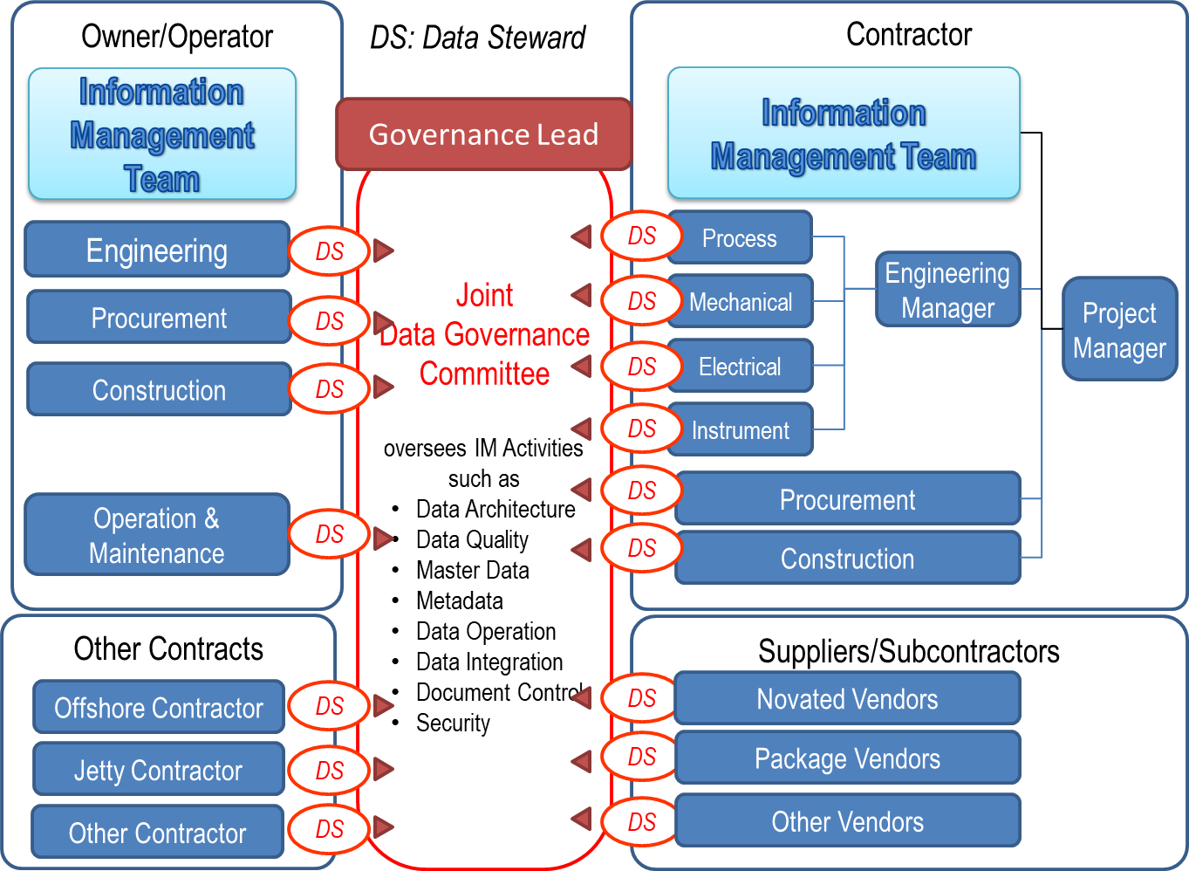
Figure 4: Typical Data/Information Governance Organization
图4 典型的数据/信息治理组织

IT Requirements IT要求

Common Data Environment (CDE) 公用数据环境（CDE）
If Principal chooses to use Common Data Environments shared with Contractor, Subcontractors, Suppliers/Manufacturers, the CDE must be identified in the contract. Proper manuals and training should be provided to those who are not familiar with the tools. (See Common Data Environment in Annex A.4)
如果委托方选择使用与承包方、分包方、供应方/制造方共享的公用数据环境，则必须在合同中确定CDE。对于不熟悉工具的人员宜提供适当的手册和培训（见附录A.4中的公用数据环境）。

Applications used by Contractor 承包方使用的应用程序
Principal may mandate the use of specific software applications, versions or templates for the development and handover of deliverables; for example, a specific software application may be specified to produce documents or 2D and 3D models. Principal may host specific applications and provide remote access to Contractor. If Principal allows the use of an alternative tool, Principal shall indicate the necessary functions to be covered by the equivalent software. If Principal does not mandate specific applications or templates, Contractor has the freedom to use whatever application or template to create the requested deliverables as far as all the requirements specified in CIS are satisfied.
委托方可指定使用特定软件应用程序、版本或模板生成和移交交付物；例如，可规定特定软件应用程序来生成文档或2D和3D模型。委托方可托管特定应用程序，并向承包方提供远程访问。如果委托方容许使用替代工具，委托方应指明等效软件所涵盖的必要功能。如果委托方未指定特定应用程序或模板，只要满足CIS中规定的所有要求，承包方有权使用任何应用程序或模板以创建要求的交付物。

IM Organization, Roles, and Responsibility IM组织、角色和职责

Stakeholders 利益相关方

Corporate Stakeholders 公司利益相关方
Capital Facility contracts involve various parties who play designated contractual roles (see Figure 5). It is important to first recognise who they are and what their roles, interests, responsibilities, and concerns are. Information flows between Principal and external parties, and Principal and EPC Contractor are the two central hubs where the information flows in and out. Principal is responsible for the information exchanged with Government or Local Authorities and the Principal’s other Contractors. EPC Contractor is responsible for the information exchanged with the Suppliers/ Manufacturers and Subcontractors. It is also important to note that Supplier/ Manufacturers are directly under Contractor during the EPC phase, but they will have maintenance contracts directly with Principal after the plant hand over.
资产密集型设施合同涉及承担指定合同角色的各方（见图5）。重要的是首先要认识到他们是谁，及他们的角色、兴趣、责任和关注是什么。委托方和外部各方之间，以及委托方和EPC承包方之间的信息流是信息进出的两个中心枢纽。委托方负责与政府或地方当局以及委托方其他承包方交换的信息；EPC承包方负责与供应方/制造方和分包方交换的信息。重要的是还要注意，供应方/制造方在EPC阶段直接隶属于承包方，但在工厂移交后将直接与委托方签订维护合同。
It is not recommended that Principal requests EPC Contractor to communicate directly with Government or Local authorities, or the other Principal’s Contractors unless they have the contractual relationships.
不推荐委托方要求EPC承包方直接与政府或地方当局或其他委托方承包方沟通，除非他们之间有合同关系。
Information hand over should be considered with respect to the contractual relationships, information owners’ intellectual properties, and information provenances.
信息移交宜考虑合同关系、信息所有者的知识产权和信息来源。
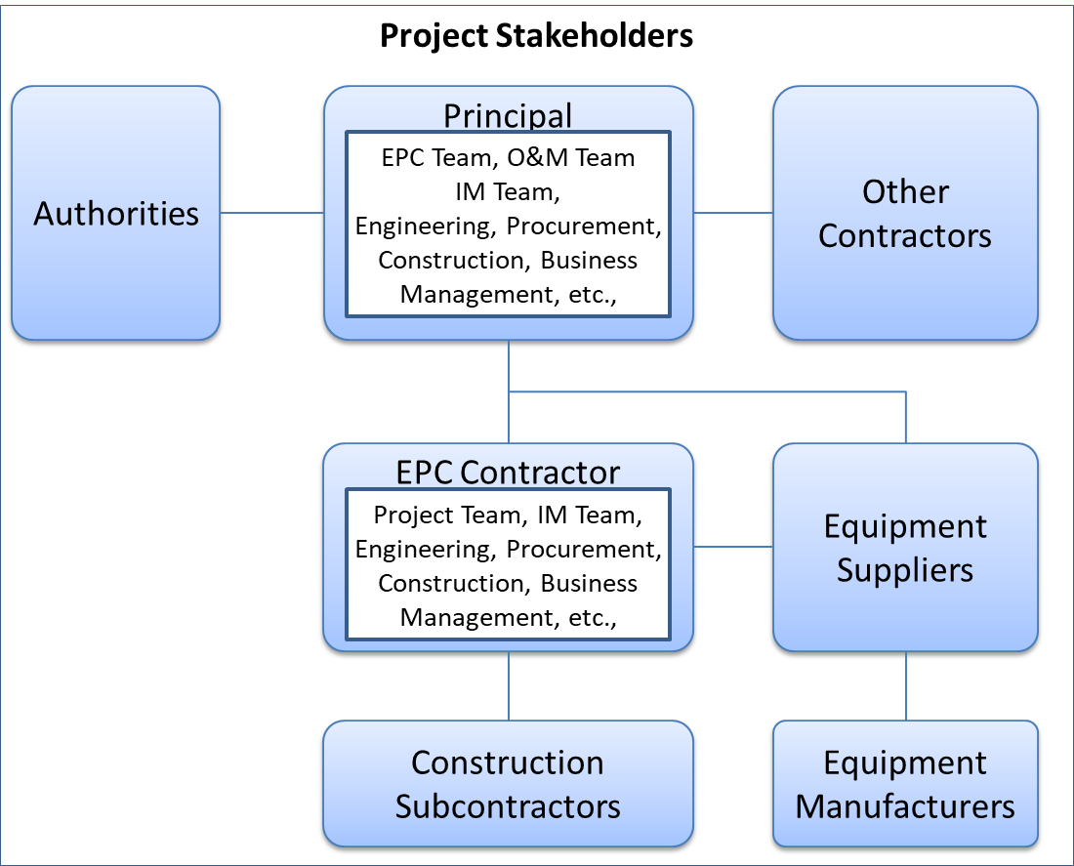
Figure 5: Project Stakeholders
图5 项目利益相关方

Internal Stakeholders 内部利益相关方
Information Management requires the collaboration of business and IT professional and encompasses various stakeholders within Principal, EPC Contractor, and Suppliers/Manufacturer. The project organizations may be different depending on projects or corporations, but a typical relationship around Information Management Team is described as Figure 6 and Figure 7.
信息管理需要业务和IT专业人员的协作，并包含委托方、EPC承包方和供应方/制造方中的各利益相关方。项目组织可因项目或公司而异，但信息管理团队的典型关系见图6和图7。
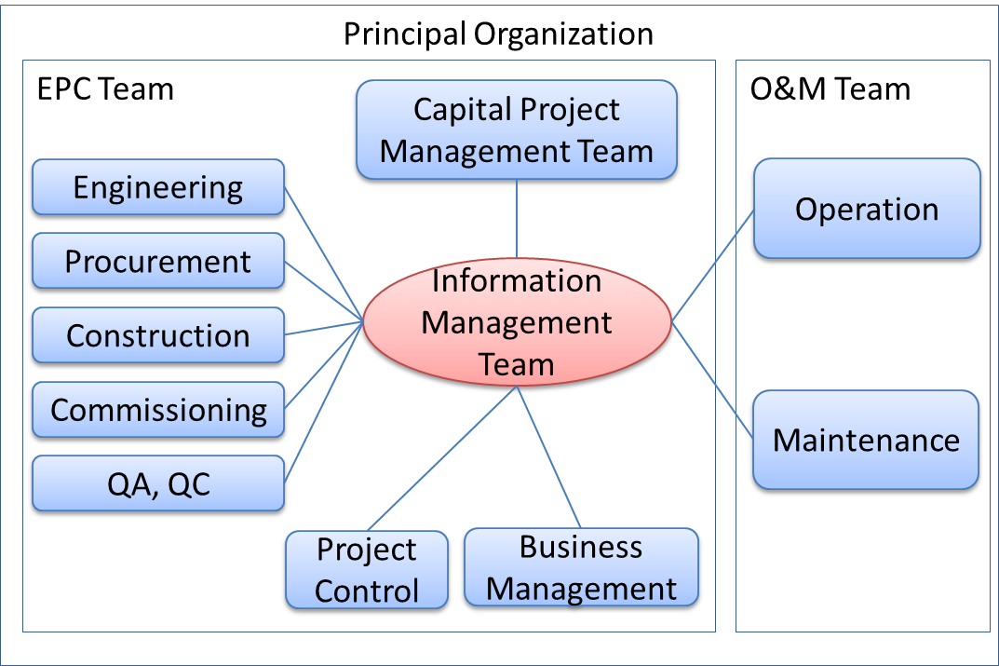
Figure 6: Principal Organization
图6 委托方组织
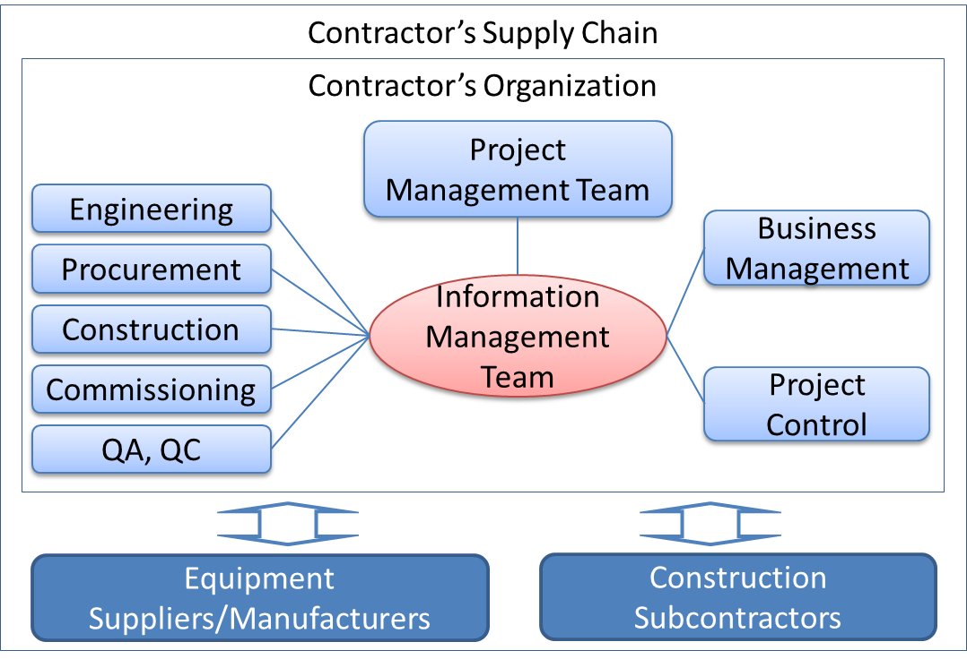
Figure 7: Contractor Organization
图7 承包方组织

Information Interfaces among Stakeholders 利益相关方之间的信息接口
In general, information flows within a company as well as outside companies. However, the official information flows among corporate stakeholders shall take place through the designated gateways of the companies. Principal, Contractor and other corporate stakeholders shall nominate, assign and delegate such gateway organization to officially exchange relevant information following the agreed procedures. The information provided by Information Supplier shall be coordinated and aligned before it is delivered to other parties.
一般来说，信息在公司内部流动，也在公司外部流动。但是，公司利益相关方之间的官方信息流应通过公司指定通道进行。委托方、承包方和其他公司利益相关方应提名、指派和委托此类通道机构遵循商定的程序正式交换相关信息。信息提供方提供的信息应在交付给其他方之前进行协调和对齐。
Under the CFIHOS framework, though numerous communications happen among engineers, managers and other personnel of various companies, Information Managers officially represent their companies and the official information shall be exchanged through the agreed procedure.
在CFIHOS框架下，虽然各公司的工程师、经理和其他人员之间会进行大量沟通，但信息经理正式代表其公司，正式信息应通过商定的程序进行交换。

Information Review and Approval Responsibilities 信息复核和批准职责
Information Supplier shall be accountable for their information quality. Information quality shall be managed at its source and Information Supplier shall not rely on Information Consumer’s reviews to comment and highlight issues. Information Supplier shall employ an internal information quality assurance process that ensures appropriate reviews are conducted by subject matter experts. Information Consumer may reject any information if such a process is not followed.
信息提供方应对其信息质量负责。应从源头管理信息质量，信息提供方不应依赖信息使用方的复核来批注和高亮问题。信息提供方应采用内部信息质量保证流程，确保主题专家进行适当的复核。如果不遵循这样的流程，信息使用方可拒绝任何信息。
Information Consumer shall also review Information Supplier’s deliverables to ensure compliance with the Information Consumer’s technical requirements. Acceptance of information by Information Consumer does not relieve Information Supplier of responsibility for design accuracy or for compliance with applicable codes, standards or contractual requirements.
信息使用方还应复核信息提供方的交付物，以确保其遵守信息使用方的技术要求。信息使用方接受信息并不能免除信息提供方对设计准确性或遵守适用规范、标准或合同要求的责任。

IM Organizations and Functions IM组织和职能
Since CFIHOS handles data and documents, it is recommended that the IM organization has the integrated functions to manage data and documents.
由于CFIHOS处理数据和文档，因此推荐IM组织具备管理数据和文档的综合职能。
In order to avoid the propagation of inconsistencies among data and documents, the IM organization shall gather, coordinate, consolidate data and documents before those are exchanged with external parties.
为避免数据和文档之间不一致的传播，IM组织应在与外部各方交换数据和文档之前收集、协调、合并数据和文档。

Principal’s IM Organization 委托方IM组织
The Principal’s IM organization shall be responsible for the requirements definitions, review and feedback comments to the Contractor’s deliverables, as well as coordination between its EPC team and O&M team so that Contractor receives consistent instructions.
委托方IM组织应负责定义要求，复核承包方交付物并反馈意见，及协调EPC团队和O&M（运维）团队，以使承包方收到一致的指示。

Contractor’s IM Organizations 承包方IM组织
The Contractor’s IM Organization shall be solely responsible for receiving the IM requirements from Principal and for implementing IM solutions by coordinating various internal stakeholders such as engineering disciplines, procurement, construction and commissioning. The Contractor’s project team is responsible for enabling its IM organization to fulfil their obligations.
承包方IM组织应全权负责接收委托方IM要求，并通过协调各内部利益相关方（如工程各专业、采购、施工和调试）实施IM解决方案。承包方项目团队负责使能其IM组织履行其义务。

Suppliers/Manufacturers’ and Subcontractors’ IM Organizations 供应方/制造方和分包方的IM组织
Contractor shall flow down IM requirements to its Suppliers/Manufacturers and Subcontractors (if required) and ensure they have IM functions in their organizations. The Suppliers/Manufacturers’ or Subcontractor’s IM teams may participate in the Principal/Contractor IM activities.
承包方应向其供应方/制造方和分包方（如需要）下达IM要求，并确保这些组织具备IM职能。供应方/制造方或分包方IM团队可参与委托方/承包方IM活动。

Joint IM Team 联合IM团队
As soon as the project commences, the joint IM team should be formed between the Principal’s and the Contractor’s IM organization. This team shall be responsible for the following:
- Metadata Management, including but not limited to RDL and Data Models
- Master Data Management
- Master Tag Register Management
- Master Document Register Management
- Change Management
- Monitoring and Reporting
- Coordination among relevant stakeholders
- Identification of IM issues and solutions as well as escalation to upper project management.
一旦项目开始，宜在委托方和承包方IM组织之间组建联合IM团队。该团队应负责以下：
- 元数据管理，包括但不限于RDL和数据模型；
- 主数据管理；
- 主位号清册管理；
- 主文档清册管理；
- 变更管理；
- 监测和报告；
- 协调利益相关方；
- 识别IM问题，确定解决方案，并向项目管理上级报告。

IM Roles, Job Descriptions, Responsibilities, and Skill Sets IM角色、工作描述、职责和技能

General 总则
The IM roles, job descriptions, responsibilities and required skill sets are described in Annex C. The Contractor’s Information Manager and other personnel may be interviewed by the Principal’s Information Manager to evaluate their experiences and skill sets.
IM角色、工作描述、职责和所需技能见附录C。可由委托方信息经理面试承包方信息经理和其他人员，以评估他们的经验和技能。

IM Roles IM角色
IM roles typically consist of the following:
- Information Management Lead (Information Manager)
- Document Control Lead
- Data Management Lead.
IM角色通常由以下组成：
- 信息管理主管（信息经理）；
- 文控主管；
- 数据管理主管。
Each of the above roles has its scope of work and responsibilities as well as required skill sets (see Annex C.1).
上述每个角色都有其工作范围和职责以及所需技能（见附录C.1）。

Data Owners and Data Stewards 数据所有者和数据管理者
Data Owners are those who produce data and ultimately responsible for the data quality in terms of accuracy, consistency, format conformity and completeness. Data Stewards are those who play the guardian role to verify and validate the data quality and report data quality issues to relevant parties. Both Data Owners and Data Stewards do not belong to the IM team but to organizations who produce and obtain the information.
数据所有者是指生成数据并最终负责数据质量的准确性、一致性、格式符合性和完整性的人。数据管理者验证和确认数据质量并向相关方报告数据质量问题的监护人。数据所有者和数据管理者都不属于IM团队，而是属于生成和获得信息的组织。
In the case of engineering, data owners are engineers who produce or approve specific Tags or Equipment data. Data Stewards are appointed by the disciplines to manage the data. The typical responsibilities of Data Stewards are:
- Understanding and managing the metadata defined in CFIHOS Specification Document [C-SP-001]
- Developing business rules, data quality rules, and data standards to ensure that disciplines follow those rules and standards
- Managing and coordinating to resolve data quality issues
- Executing operational data governance activities, and responsible for ensuring that day-to-day data governance policies and initiatives are adhered to
- Monitoring, reporting and escalating issues to Data Governance organization.
就工程而言，数据所有者是生成或批准特定位号或设备数据的工程师。数据管理者由专业任命来管理数据。数据管理者的典型职责是：
- 理解和管理CFIHOS规范[C-SP-001]中定义的元数据；
- 制定业务规则、数据质量规则和数据标准，以确保各专业遵循这些规则和标准；
- 管理和协调，以解决数据质量问题；
- 开展运行数据治理活动，负责确保日常数据治理遵守数据治理策略和计划；
- 监测、报告问题，上报数据治理组织。

Information Management Process and Activities 信息管理过程和活动

Information Management Process Overview 信息管理过程概述
Between Principal and Contractor, the IM process starts at the pre-bidding phase and continues until the completion of the Contract as shown in Figure 8.
在委托方和承包方之间，IM过程从投标前阶段开始，一直持续至合同完成，见图8。
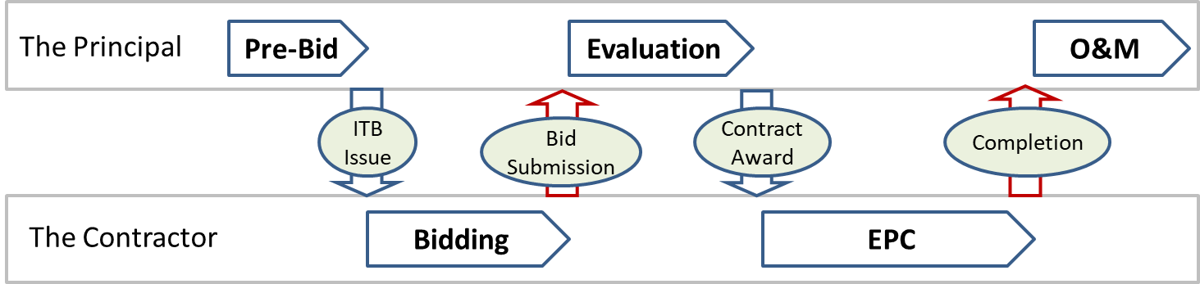
Figure 8: Project Phases
图8 项目阶段
Table 3 shows typical actions taken at each phase.
每个阶段采取的典型行动见表3。
Table 3: Actions in each phase
表3 各阶段行动
Phase  阶段 | Action  行动 | Principal  委托方 | EPC Contractor  EPC承包方
Pre-Bid  投标前 | Preparation of ITB to EPC Contractor using the CFIHOS Implementation Guide  使用CFIHOS实施指南准备给EPC承包方的ITB。 | O
Pre-Bid  投标前 | Where Principal intends to novate an order or agreement to Contractor, preparation of ITB to Suppliers/Manufacturers using the CFIHOS Implementation Guide  如果委托方预期更换给承包方的订单或协议，使用CFIHOS实施指南准备给供应方/制造方的ITB。 | O
Bidding  投标 | IM related technical clarifications and Answers  IM相关技术澄清及答复。 | O | O
Upon Bid Submission  递标时 | Express the degree of compliance with CFIHOS  表达CFIHOS合规度。 |  | O
Evaluation  评标 | Compare EPC Contractors bids on compliance with CFIHOS  比较EPC承包方的投标是否遵守CFIHOS。 | O
Upon Contract Award  合同授予时 | Issue a set of Reference Data Libraries  发布一套参考数据类库。 | O
EPC（设计、采购与施工） | When Principal requests EPC Contractor to accept novated order or agreement, the consistency between the novated order or agreement and the contract with EPC Contractor should be confirmed.  当委托方要求EPC承包方接受替代订单或协议时，宜确认替代订单或协议与EPC承包方合同的一致性。 | O | O
EPC（设计、采购与施工） | Carry out the Kick-off meeting and regular meetings between Principal and EPC Contractor  召开委托方和EPC承包方之间的启动会和例会。 | O | O
EPC（设计、采购与施工） | Issue EPC Contractor's IM documents  发布EPC承包方的IM文档。 |  | O
EPC（设计、采购与施工） | Reviews and comments to the EPC Contractor's IM documents by Principal  委托方复核及批注EPC承包方的IM文档。 | O
EPC（设计、采购与施工） | Establish Data Governance procedure  建立数据治理程序。 | O | O
EPC（设计、采购与施工） | Complete IT environment  完善IT环境。 | O | O
EPC（设计、采购与施工） | Ensure Supplier/Manufacturer’s compliance with the CFIHOS requirements  确保供应方/制造方遵守CFIHOS要求。 | O | O
EPC（设计、采购与施工） | Data gathering from Suppliers/Manufacturers  收集供应方/制造方数据。 |  | O
EPC（设计、采购与施工） | Information Handover at the frequency specified  按规定频次移交信息。 |  | O
EPC（设计、采购与施工） | Review, comment, approval or rejection of the information handed over  复核、批注、批准或拒绝移交的信息。 | O
EPC（设计、采购与施工） | Prepare IT environment for Principal for operation and maintenance  为委托方运维准备IT环境。 | O
Upon Completion  竣工时 | As-Built information handover  移交竣工资料。 |  | O
Upon Completion  竣工时 | Review, comment, approval or rejection of the As-Built information  复核、批注、批准或拒绝竣工资料。 | O

Pre-Bidding Phase 投标前阶段
Principal shall refer to CFIHOS Implementation Guide [C-GD-001] when producing the EPC Contract considering the following points.
委托方制定EPC合同时，应参考CFIHOS实施指南[C-GD-001]，并考虑以下几点。

Information handover requirements in the Contract 合同信息移交要求
Since complete and accurate information is crucial for the safe and efficient operation of a plant, Principal shall issue a Contract Information Management Scope of Work and the information specifications to define the specific deliverables for a particular contract. Descriptions shall be unambiguous which information (data and documents) are to be delivered, and when and in which format it should be delivered. Principal shall also define details of the timing, frequency, and method for information hand over in a Contract Information Management Scope of Work.
完整和准确的信息对于工厂的安全和高效运行至关重要，因此委托方应发布合同信息管理工作范围和信息规范，以确定特定合同的具体交付物。其中应无二义性地描述哪些信息（数据和文档）应交付，宜何时以何种格式交付。委托方还应在合同信息管理工作范围中详细定义信息移交的时间、频次和方法。

IM related documents to be produced by Contractor 要由承包方编制的IM相关文档
Principal may mandate the following documents to be submitted by Contractor at the bidding phase or EPC phase. The expected contents, level of details, and submission deadlines shall also be specified.
- IM Philosophy, Plan and Procedure
- Data Management and Data Governance Plan and Procedure
- IT Plan and Procedure
- Document Management Plan and Procedure
- Correspondence Management Plan and Procedure
- Interface Management Plan and Procedure
- Model Management Plan and Procedure
- BIM Execution Plan and Procedures.
委托方可指定承包方在投标阶段或EPC阶段提交以下文档，还应规定期望内容、详细程度和递件截止日期。
- IM方法、计划和程序；
- 数据管理和数据治理计划和程序；
- IT计划和程序；
- 文档管理计划和程序；
- 通信管理计划和程序；
- 接口管理计划和程序；
- 模型管理计划和程序；
- BIM执行计划和程序。
These documents shall show how Contractor plans to satisfy the CFIHOS requirements. Principal may also request Contractor to demonstrate the capabilities to achieve the desired results.
这些文档应表明承包方计划如何满足CFIHOS要求。委托方也可要求承包方证实其达到预期结果的能力。

Consistency among the Contracts 合同间一致性
Principal shall ensure the consistency among the CFIHOS related contract conditions for EPC Contractor and Suppliers/Manufacturers.
委托方应确保EPC承包方和供应方/制造方的CFIHOS相关合同条件之间的一致性。

Bidding, Bid Submission, and Evaluation Phase 投标、递标和评标阶段

Clarifications and answers 澄清和答复
To avoid misunderstanding and enforce clarities instead, Contractor may raise IM related clarifications to Principal. It is important that Principal and Contractor share the same understanding of the IM requirements.
为避免误解、加强明确性，承包方可向委托方提出IM相关澄清。重要的是委托方和承包方对IM要求的理解相同。

IM related deviations and alternatives IM相关偏离和替代
Contractor may request deviations or submit alternative proposals for approval if they deem fit for the purpose by Principal. These proposals shall be submitted with reasons and details enough to prove that Contractor still satisfies the CFIHOS requirements.
如果承包方认为适合委托方目的，承包方可要求偏离或提交替代建议供批准。应在提交这些建议时充分说明理由和细节，以证明承包方仍然满足CFIHOS要求。
Contractor shall state its compliance with, alternatives to, or deviations from the CFIHOS requirements at the bid submission.
承包方应在递标时明示其是否遵守、替代或偏离CFIHOS要求。

On Contract Award 合同授予时

Adjustment of CFIHOS requirements CFIHOS要求的调整
As a standard contracting practice, if deviations or alternatives are accepted by Principal, the Contract shall incorporate those agreed terms and shall be adjusted accordingly.
作为一种标准的合同实践，如果委托方接受偏离或替代，则合同应纳入这些商定的条款，并应进行相应调整。

Project Dictionary and Classification 项目字典和分类
Principal shall formally issue Contractor a set of CFIHOS RDL [C-ST-001] at the commencement of the Contract including the following:
- Tag Classes and Properties Definitions
- Equipment Classes and Properties Definitions
- Document Classes Definitions
- Model Classes and Model Definitions.
委托方应在合同开始时正式向承包方发布一套CFIHOS RDL[C-ST-001]，包括以下：
- 位号类和特性定义；
- 设备类和特性定义；
- 文档类定义；
- 型号类和型号定义。
Contractor shall ensure all information delivered to Principal complies with the RDL. Where Contractor is unable to utilize the definitions and naming conventions in the RDL directly in its business processes and applications, Contractor shall map and convert their reference data to the Principal’s RDL so that the resulting information will still satisfy the RDL.
承包方应确保交付给委托方的所有信息符合RDL。如果承包方无法在其业务流程和应用程序中直接使用RDL中的定义和命名规范，承包方应将其参考数据映射并转换为委托方RDL，以便生成的信息仍然满足RDL。
Application of the RDL by Contractor shall determine the Principal’s information requirements, for example:
- If a Tag is classified as a centrifugal pump, the reference data will identify which properties for that pump need to be delivered by Contractor. The property requirements are different if a different classification is used
- If a Document is classified as a “Process Engineering Flow Scheme”, this class identifies that the final status of the document shall be handed over at As-Built, when a native file format is required (at handover, during project or not required) and a document’s representation type (e.g., structured data).
承包方应用RDL将确定委托方信息要求，例如：
- 如果某位号分类为离心泵，则参考数据将确定承包方需要交付该泵的哪些特性。如果使用不同的分类，则特性要求不同；
- 如果某文档分类为“工艺流程图”，此类确定该文档的最终状态应以竣工状态移交，及要求源文件格式的时间（移交时、项目期间或不要求），和文档表示类型（如结构化数据）。
Principal may revise the RDL during the execution of the works. Principal shall formally transmit any updates to Contractor, highlighting any changes. Contractor shall replace any earlier revisions of the reference data and ensure future compliance with the new revision.
委托方可在工作执行期间修订RDL。委托方应将任何更新正式传送给承包方，高亮任何变更。承包方应替换参考数据的早期版本，并确保遵守新版本。
If Contractor is unable to comply with any of the requirements resulting from the application of the Principal’s RDL, Contractor shall obtain written permission from Principal for any deviations.
如果承包方因应用委托方RDL而导致无法遵守任何一项要求，承包方应就所有偏离获得委托方书面许可。

Provision of Model Configuration Files 提供模型配置文件
Principal shall formally issue Contractor a set of engineering tool configuration files like seed files, which shall be consistent with the RDL definitions.
委托方应正式向承包方发布一套工程工具配置文件（如种子文件），这些文件应与RDL定义一致。

EPC Phase EPC阶段

Kick-off Meeting and regular meetings 启动会和例会
Achieving the CFIHOS goals requires joint efforts among Principal, EPC Contractor, Suppliers/ Manufacturers and/or Subcontractors. To facilitate the communication, EPC Contractor shall plan, request and conduct an immediate a kick-off meeting with Principal with the following agendas:
- Explanation and confirmation of the CFIHOS requirements by Principal
- Confirmation of schedules and milestones by both parties
- Confirmation of communication methods between parties
- IM organization and assignments of roles
- Detail clarifications and answers by both parties
- Plan for IM regular meetings.
实现CFIHOS目标需要委托方、EPC承包方、供应方/制造方和/或分包方共同努力。为加强沟通，EPC承包方应计划、要求并立即与委托方召开启动会。会议议程如下：
- 委托方解释和确认CFIHOS要求；
- 双方确认进度和里程碑；
- 确认各方之间沟通方式；
- IM组织和角色分配；
- 双方就细节进行澄清和答复；
- IM例会计划。

Submission of Contractor’s IM related documents 承包方提交IM相关文档
EPC Contractor shall submit specified IM related documents to Principal for review and approval according to the designated milestones. EPC Contractor shall hold workshops with Principal to explain the intention and implementation plans as written in those documents and to receive feedback from Principal.
EPC承包方应按指定的里程碑提交规定的IM相关文档给委托方供复核和批准。EPC承包方应与委托方举办研讨会，解释这些文档所述意图和实施计划，并获取委托方反馈。

Data Management and Data Governance Activities 数据管理和数据治理活动
As soon as Principal and EPC Contractor establish IM organization and roles, data management and data governance activities should commence according to the agreed plans and procedures. The following should be focused as priorities for those activities.
- Data management activities to satisfy the information quality indicated in CIS
- Document management programs and workflows
- Establishing the project data governance team
- Assigning the data stewards representing various disciplines who are responsible for the data, information and documents the disciplines produce
- Tags and equipment data management activities:
  - Tracking estimated number of tags and pieces of equipment
  - Tracking the progress of tag and equipment data gathering.
- Validation and consistency check results for:
  - Tags and equipment data
  - Tag to tag relations
  - Document to tag, tag to document relations
  - Document to document relations.
一旦委托方和EPC承包方设立IM组织和角色，宜即按商定的计划和程序开展数据管理和数据治理活动，其重点宜放在以下优先项：
- 数据管理活动，以满足CIS指明的信息质量；
- 文档管理程序和工作流程；
- 建立项目数据治理团队；
- 指派代表各专业的数据管理者，负责各专业生成的数据、信息和文档；
- 位号和设备数据管理活动：
  - 跟踪估算位号个数和设备台数；
  - 跟踪位号和设备数据收集进度。
- 确认以下并检查结果一致性：
  - 位号与设备数据；
  - 位号至位号关系；
  - 文档至位号、位号至文档间关系；
  - 文档至文档关系。
EPC Contractor is ultimately responsible for data gathering through the Information Supply Chain including the data provided by its suppliers/Manufacturers. However, EPC Contractor and Principal should conduct the joint effort to expedite the data gathering from the Information Supply Chain.
EPC承包方最终负责通过信息供应链收集数据，包括其供应方/制造方提供的数据。但是，EPC承包方和委托方宜共同努力加快信息供应链的数据收集。

On Contract Completion 合同完成时
Contractor shall submit all the As-Built Information/Data to Principal accurately reflecting the Tags and physical Equipment built into the facility, within the specified period after the physical facility handover, by incorporating the As-Built information into documents and drawings and the final MDR and MTR.
承包方应通过将竣工信息纳入文档和图纸及最终MDR和MTR，在物理设施移交后的规定期限内，向委托方提交准确反映设施内的位号和物理设备的所有竣工信息/数据。

During Operation and Maintenance 运维期间
The Data and Documents shall be kept updated when any changes occur during the operation and maintenance period by Principal. Lessons Learnt and continuous improvements shall be incorporated for the subsequent projects.
委托方在运维期间进行任何变更时，应更新数据和文档。后续项目应吸取经验教训并持续改进。

Decommissioning of Plant 工厂退役
Principal may decide what to do with the data and documents when the plant is de-commissioned.
委托方可决定当工厂退役时如何处理数据和文档。

Bibliography 参考文献
- ISO 19005-1:2005 Document management - Electronic document file format for long-term preservation 文献管理 长期保存的电子文档文件格式
- ISO/IEC 27001, 27002 Information security management systems 信息安全管理体系
- ISO 8000 Data Quality 数据质量
- ISO 9000 Quality management 质量管理
- BS1192 and PAS1192, Building Information Modelling 建筑信息模型
- DAMA International (2017), Data Management Body Of Knowledge 2nd Edition 数据管理知识体系第2版

Annex A: Building Information Modelling
附录A 建筑信息模型
  - General 总则
Refer to BS1192 and PAS1192 (British Standards and Publicly Available Specifications from BSI) for additional information on the BIM concept and Figures relating to Information Hand Over including the related management processes, and nature and types of information. The process starts with the Employer’s Information Requirements (Principal’s Information Requirements in CFIHOS) and leads to the BIM Execution Plan and Master Information Delivery Plan. The BIM concept differentiates plant related information into two categories, one is a Project Information Model, and the other is an Asset Information Model.
参考BS1192和PAS1192（英国标准和BSI PAS（可公开获得规范）），了解与信息移交有关的BIM概念和配图的更多信息，包括相关的管理流程、信息的性质和类型。该流程从雇主的信息要求（CFIHOS中的委托方信息要求）开始，直至BIM执行计划和主信息交付计划。BIM概念将工厂相关信息分为两类：一类是项目信息模型，另一类是资产信息模型。
  - Project Information Model - Work in Progress 项目信息模型——工作进行中
Project Information Model is the documents, non-graphical data, and graphical data which are still work in progress and subject to change. Therefore, they are not used for the Principal’s operation and maintenance.
项目信息模型是指仍在工作进行中且可能变更的文档、非图形数据和图形数据，因此不用于委托方运维。
  - Asset Information Model – Archives 资产信息模型——档案
Asset Information Model, on this other hand, are As-built information at the time of the physical plant handover, which are used for operation and maintenance.
另一方面，资产信息模型是物理工厂移交时的竣工信息，用于运维。
Principal or Contract may elect to demand Project Information Model to be included in the Information Handover plan.
委托方或承包方可选择要求将项目信息模型纳入信息移交计划。
  - Common Data Environment (CDE) CDE（公用数据环境）
The Common Data Environment is a concept to share, review, publish, and maintain the data and documents. CDE is meant to achieve the ‘Single Source of Truth’ principle, though it may be built physically by using multiple IT environments such as electric document management and multiple databases.
公用数据环境是一个共享、复核、发布和维护数据和文档的概念。CDE旨在实现“单一可信源”原则，尽管其在物理上可通过使用多个IT环境（如电子文档管理和多个数据库）构建。
CDE manages Project Information Model and Asset Information Model where different stakeholders may be interested in either model.
CDE管理项目信息模型和资产信息模型，不同的利益相关方感兴趣的模型可不同。

Annex B: Transmittal
附录B 传送单
  - General 总则
All the CFIHOS related documents shall be delivered with transmittals through EDMS. This annex shows typical examples of how it is organized. How a transmittal should be organized and transmitted for a Project shall be specified in the Contract by Principal.
所有CFIHOS相关文档应附传送单通过EDMS交付，其组织方式的典型示例见本附录。委托方应在合同中规定宜如何组织和传送项目传送单。
  - Components in a Transmittal 传送单组件
A transmittal may contain the following components. Those components do not necessarily represent physical files if a certain EDMS is used.
The Transmittal: | contains the metadata of the Primary File, the Native Files, the Additional Files and the Index File and may be created automatically by EDMS or created manually in a separate file as a cover page.
Primary File: | is a file registered in Master Document Register submitted, usually in a single PDF file.
Native Files: | are used to build the Primary File. A single PDF file can be produced by multiple native files such as MS Word and MS Excel files converted to form the PDF.
Reference Files: | are any additional files to supplement the submission
Index File: | contains an index showing which files are attached to the submission;
Zip File: | packages other files;
传送单可包含以下组件。如使用某些EDMS，这些组件未必表示物理文件。
传送单： | 包含主文件、源文件、附加文件和索引文件的元数据，可由EDMS自动创建，也可作为封面页在单独的文件中手动创建。
主文件： | 是在MDR中注册并提交的文档，通常是单一PDF文件。
源文件： | 用于构建主文件。单一PDF文件能由多个源文件（如转换后构成PDF的MS Word和MS Excel文件）生成。
参考文件： | 补充递件的任何附加文件。
索引文件： | 包含表明递件随附文件的索引。
压缩文件： | 其他文件的打包。
  - Transmittal and Transmission Options 传送单和传送选项
    - Transmittal Options 传送单选项
Table B.1 shows various transmittal options that can be adopted by Principal. The combinations of those options will form the requirements of document submissions. Please note some of options may be dependent on other options.
委托方能采用的各种传送单选项见表B.1。这些选项的组合构成文档递件要求。
注：某些选项可依赖于其他选项。
Table 4: Transmittal Options
表B.1 传送单选项
Options  选项 | Choice  选择 | Description  描述
Zip Option  压缩选项 | Allow Zip  容许压缩 | Zip file(s) can be used in document submissions.  压缩文件能用于文档递件。
 | Prohibit Zip  禁止压缩 | Zip files not allowed in document submissions.  文档递件中不容许使用压缩文件。
Password Option  密码选项 | Allow Password Protection  容许密码保护 | Documents can be or shall be protected by passwords. In this case, Principal specifies password properties (eg strength) and how the password is transmitted.  文档能或应采用密码保护。在这种情况下，委托方指定密码特性（如强度）和密码传送方式。
 | Prohibit Password Protection  禁止密码保护 | Documents shall not be protected by passwords.  文档不应采用密码保护。
Single or Multiple File Option  单个或多个文件选项 | Single File  单个文件 | Only one file is allowed in a single document submission where multiple files can be combined in one zip file if the zip is allowed.  单一文档递件只容许一个文件，如果容许压缩，则能将多个文件合并至一个压缩文件。
 | Multiple Files  多个文件 | Multiple files can be contained in a single document submission  单一文档递件能包含多个文件。
Transmittal Creation Option  传送单创建选项 | Manual Transmittal  手动传送单 | When EDMS does not create a transmittal, it shall be created manually and shall contain all the required information as a cover page.  EDMS不创建传送单。应手动创建，并应在封面页包含所有要求信息。
 | EDMS Transmittal  EDMS传送单 | When EDMS creates a transmittal such as Aconex, the form and the document metadata of the transmittal should be defined for the document submission.  EDMS创建传送单时，宜为文档递件定义传送单的结构和文档元数据。
Index File Option  索引文件选项 | Separate Index File  单独索引文件 | Index of files should be created as a separate file  文件索引宜创建为单独的文件。
 | Index Information  索引信息 | Index information can be described as a table in the Transmittal itself or in the cover page.  索引信息能用传送单本身或封面页中的表格描述。
    - Transmission Method Options 传送方法选项
The mechanism for transferring the Transmittals between Principal and Contractor shall be agreed at the commencement of the contract period. The following table shows various transmission options that can be adopted by Principal.
应在合同开始时商定委托方和承包方之间传送单的传输机制。委托方能采用的各种传送选项见下：
Shared EDMS:
Principal may instruct Contractor to directly access the Principal’s EDMS. In such a case, documents are submitted using the EDMS application. Principal shall specify the following elements:
- Authentication: User ID and password to access the EDMS
- Permission: Which roles are provided and what actions are allowed for the roles
- System Information: Specific requirements such as browser types and versions and system constraints
- Manuals and Training: Principal may provide the user manual, training or workshops for Contractor to become familiarized
- Workflow Specifications: Types of workflows to be used for Contractor.
共享EDMS：
委托方可指示承包方直接访问委托方EDMS，这种情况下使用EDMS应用程序提交文档。委托方应对以下要素做出规定：
- 身份验证：访问EDMS的用户ID和密码；
- 权限：提供哪些角色，容许哪些角色执行哪些操作；
- 系统信息：浏览器类型、版本、系统约束等具体要求；
- 手册和培训：委托方可提供使承包方熟悉EDMS的用户手册、培训或研讨会；
- 工作流规范：承包方使用的工作流程类型。
FTP and Shared Folders;
FTP Site
Upon contract award, Principal and Contractor establish shared folders allowing each other to access. The following elements shall be specified.
- Protocol: Port and the types of FTP shall be specified (Which port used for which protocol is allowed such as basic FTP with Port 21, SFTP or FTPS
- Authentication: User ID and password to access the shared folder
- Permission: Which folders can be accessed with which permission such as download, upload, edit, move or delete
- Maximum File Size and Total Capacity: The maximum size of files for upload and what to do when the total folder capacity is reached.
FTP和共享文件夹；
FTP站点
委托方和承包方在合同授予后建立容许彼此访问的共享文件夹，这种情况下应对以下要素做出规定：
- 协议：应规定端口和FTP类型（容许哪种协议使用哪个端口，如基本FTP（使用端口21）、SFTP或FTPS）；
- 身份验证：访问共享文件夹的用户ID和密码；
- 权限：哪些文件夹能通过哪些权限进行访问，如下载、上传、编辑、移动或删除；
- 最大文件大小和总容量：上传文件的最大大小，及达到文件夹总容量时要执行的操作。
Notification
When a transmittal is uploaded to the shared folder, the sender shall notify the receiver by sending an E-mail containing a clear reference to the Transmittal number and its location in the shared folder.
通知
当传送单上传至共享文件夹时，发送方应发送一封电子邮件通知接收方，其中明确引用传送单编码及其在共享文件夹中的位置。
HTTP and Shared Folders:
This option is the same as above FTP except that a different port and protocol is used such as HTTP or HTTPS.
HTTP和共享文件夹：
此选项与上述FTP相同，只是使用不同的端口和协议，如HTTP或HTTPS。
Web API (Application Programming Interface):
Principal may allow Contractor to use the Web Api provided by Principal, in which case the following elements shall be specified:
- Authentications and Permissions: see above in FTP
- Web Api specifications: Url, parameters, and other HTTP specifications such as HTTP methods (GET, POST, PUT, PATCH, DELETE), header, authorization and body.
Web API（应用编程接口）：
委托方可容许承包方使用委托方提供的Web API，这种情况下应对以下要素做出规定：
- 身份验证和权限：见上述FTP相关内容；
- WebAPI规范：URL、参数和其他HTTP规范，如HTTP方法（GET、POST、PUT、PATCH、DELETE）、标头、授权和正文。
  - Examples 示例
    - Combinations of Transmission Options 传送选项组合
Two examples are presented to show how the options can be applied (see Table B.2).
展示这些选项能如何应用的两个示例见表B.2：
Table 5: Transmission Options
表B.2 传送选项
Options  选项 | Example 1  例1 | Example 2  例2
Zip  压缩 | Use Zip  使用压缩 | No Zip allowed  不容许压缩
Password  密码 | No password allowed  不容许使用密码 | No password allowed  不容许使用密码
Multiple File  多个文件 | Multiple Files in Single Zip File  多个文件打包为单个压缩文件 | Multiple Files allowed  容许多个文件
Transmittal Creation  传送单创建 | Manual Transmittal  手动传送单 | EDMS Transmittal  EDMS传送单
Index  索引 | Separate Index File  单独索引文件 | Index in the Transmittal  传送单中索引
Transmission  传送 | FTP Upload/download  FTP上传/下载 | Shared EDMS  共享EDMS
    - Example 1 示例1
In this example, a transmittal carries only one file in the Zip format containing Cover Page, Index File, Primary File, Native Files and Reference Files (see Figure B.1).
本示例中，一张传送单只带一个压缩格式的文件，其中包含封面页、索引文件、主文件、源文件和参考文件（见图B.1）。
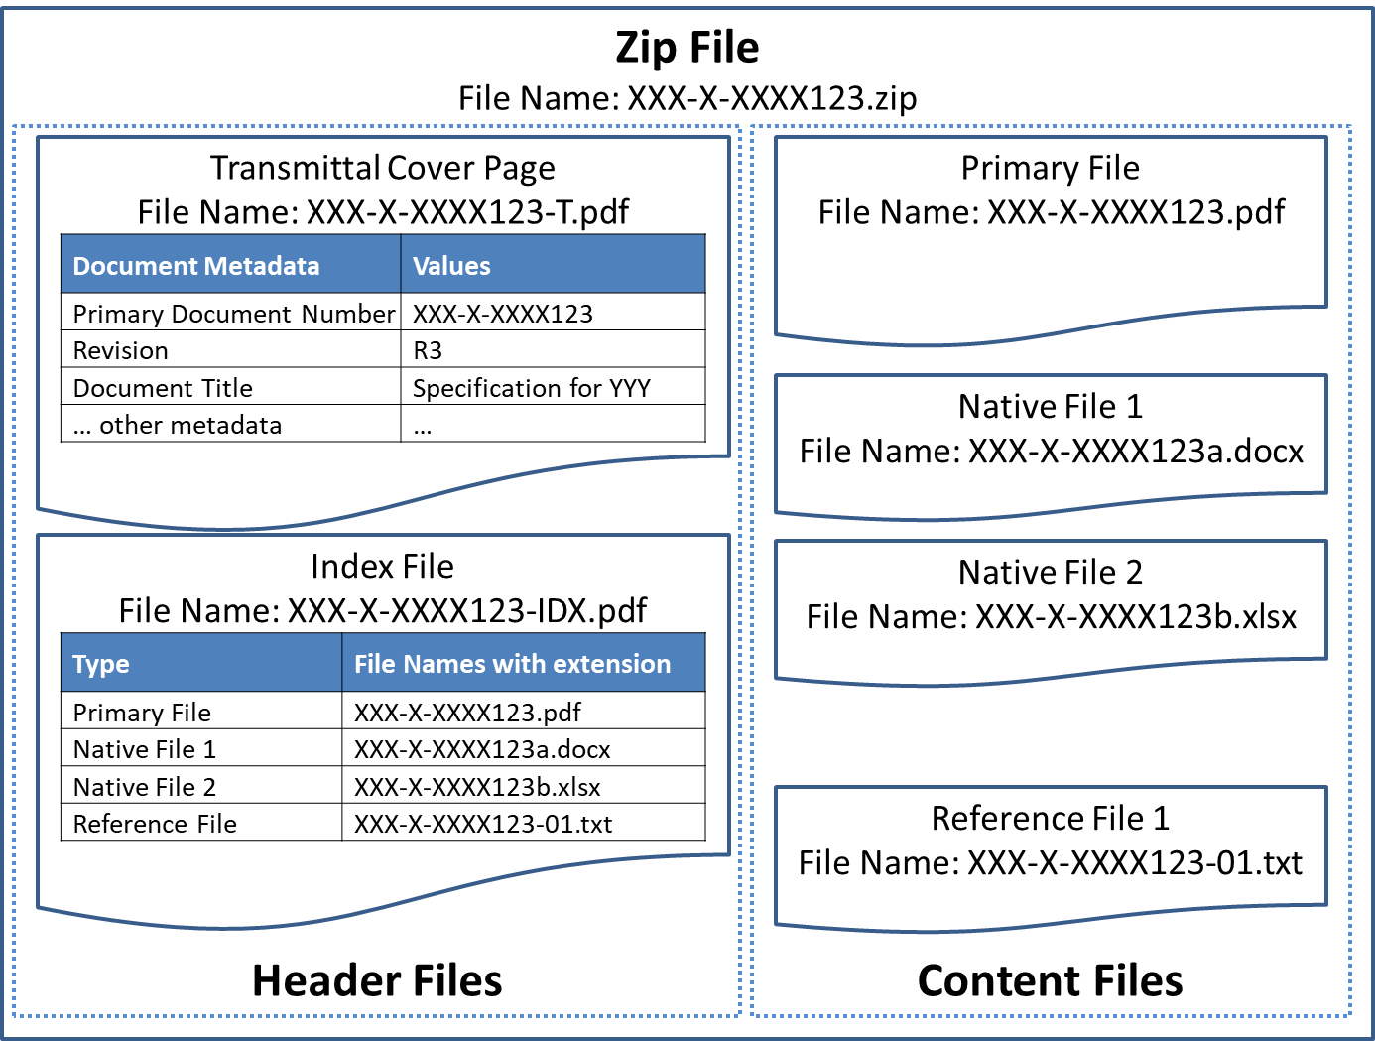
Figure 9: Zip File Case
图B.1 压缩文件案例
    - Example 2 示例2
In this example transmittals are created using an EDMS, where document metadata are stored in the system. The transmittal can contain textual description and index in a table format together with attachments containing Primary File, Native Files and Reference Files (see Figure B.2).
本示例中，传送单用EDMS创建，其中文档元数据存储在系统中。传送单能包含文本描述和表格格式的索引，以及包含主文件、源文件和参考文件的附件（见图B.2）。
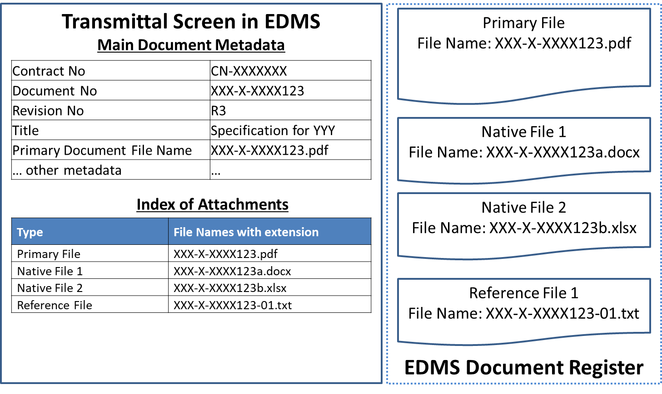
Figure 10: EDMS Case
图B.2 EDMS案例

Annex C: IM Job Description
附录C IM工作描述
  - Information Management Roles and Job Description 信息管理角色和工作描述
Information Management is typically conducted by an IM team consisting of various IM roles. Each role in the IM team of Principal shall have its corresponding role of Contractor. Major IM roles are:
- Information Management Lead (Information Manager)
- Document Control Lead
- Data Control Lead.
IM（信息管理）通常由各种IM角色组成的IM团队执行。委托方IM团队中每个角色应有其对应的承包方角色。主要IM角色有：
- 信息管理主管（信息经理）；
- 文控主管；
- 数据控制主管。
All the above roles focus on consistent application of Information Management processes relating to the delivery of project scopes. The functions, tasks, responsibilities, and skill sets that are common to all the IM roles are:
- Collaboration between Principal and Contractor to ensure that the requirements for overall IM processes are understood and adhered to
- Demonstrated leadership skills and collaboration with other leadership positions
- Fair understanding of EPC business processes
- Demonstrated familiarity with IM tools and systems typically Electronic Document Management System, Collaboration Systems, and Data Validation tools
- Proficient in IM software applications.
以上所有角色的工作重点是项目范围交付相关信息管理流程的持续应用。所有IM角色共有的职能、任务、职责和技能是：
- 委托方和承包方协作，以确保理解并遵守整个IM流程的要求；
- 证实具备领导才能和与其他领导岗位协作的能力；
- 充分理解EPC业务流程；
- 证实熟悉IM工具和系统，典型的如电子文档管理系统、协同系统和数据确认工具；
- 精通IM软件应用。
The sections below describe functions, tasks, responsibilities and skill sets expected for each IM role.
以下各条描述每个IM角色的职能、任务、职责和技能。
  - Information Management Lead 信息管理主管
    - Main Functions 主要职能
Information Management Lead in any parities shall be familiar with Information Management best practices and industrial standards.
各方信息管理主管均应熟悉信息管理最佳实践和行业标准。
The Principal’s Information Management Lead shall:
- Collaborate with the Principal’s Production organization to ensure Operations needs are met, resources are well integrated into routing and approval processes, and stewarding Handover process between Project Team and Operations
- Communicate IM key performance indicators and issues to project team, central support organization(s) and local operations organization
- Responsible for information hand over to Operations
- Liaise continually with Operations Management to ensure effective integration and support.
委托方信息管理主管应：
- 与委托方生产组织协作以确保满足运行需要，在工作路径和批准流程中合理整合资源，并管理项目团队与运行之间的移交流程；
- 与项目团队、中心支持组织和当地运营组织沟通IM关键绩效指标和问题；
- 负责将信息移交给运行；
- 与运行管理持续保持联络，以确保有效集成和支持。
The Contractor’s Information Management Lead shall:
- Collaborate with the Principal’s Information Management Lead to ensure the requirements are met, resources are well integrated into routing and approval processes, and stewarding Handover process between Principal and Contractor
- Communicate IM key performance indicators and issues with the project team.
承包方信息管理主管应：
- 与委托方信息管理主管协作以确保达到要求，在工作路径和批准流程中合理整合资源，并管理委托方与承包方之间的移交流程；
- 与项目团队沟通IM关键绩效指标和问题。
    - Tasks and Responsibilities 任务与职责
Responsibilities of the Contractor’s Information Management Lead may include any or all of the following, depending on the specific needs of the assignment:
- Be familiar with all Contract Scopes of Work and all the Project IM requirements
- Have ultimate responsibility for IM planning and management of documents, data, and models
- Develop and maintain the Project IM Strategy and Plan ensuring compliance with the Project IM requirements
- Stay abreast of application of IM processes within the EPC(s) and promote consistency
- Effectively execute IM Plans, Document Numbering Schemes, Distribution Matrix, and supporting procedures
- Develop the Information Handover Plan to facilitate the transfer of relevant information from Contractor to Principal.
承包方信息管理主管的职责根据任务的具体需要可包括以下任何一项或全部：
- 熟悉所有合同工作范围和所有项目IM要求；
- 对IM计划、文档、数据和模型的管理负最终责任；
- 制定并维护项目IM战略和计划，以确保遵守项目IM要求；
- 及时了解EPC中IM流程的应用并推进一致性；
- 有效执行IM计划、文档编码方案、分发矩阵和支持程序；
- 制定信息移交计划，以备承包方向委托方传输相关信息。
    - Required Skill Sets and Experience for the Contractor’s Information Management Lead 承包方信息管理主管所需技能和经验
- Understanding of the importance of data, information, and document assets
- Experience in major EPC projects as Information Management Roles
- Familiarity with data models, metadata, data quality, information security, document management and data governance based on the standards that Principal specifies.
- 理解数据、信息和文档资产的重要性；
- 有在大型EPC项目中担任信息管理角色经验；
- 熟悉基于委托方指定标准的数据模型、元数据、数据质量、信息安全、文档管理和数据治理。
  - Document Control Lead 文控主管
    - Main Functions 主要职能
The Principal’s Document Control Lead shall:
- Collaborate with Contractor to ensure requirements for overall Information Management processes are understood and adhered to
- Collaborate with the Production organization to ensure Operations needs are met, resources are well integrated into routing and approval processes, and stewarding Handover process between Project Team and Operations.
委托方文控主管应：
- 与承包方协作以确保理解并遵守总体信息管理流程的要求；
- 与生产组织协作以确保满足运行需要，在工作路径和批准流程中合理整合资源，并管理项目团队与运行之间的移交流程。
    - Tasks and Responsibilities 任务与职责
Responsibilities of a Document Control Lead may include any or all of the following, depending on the specific needs of the assignment:
- Be familiar with and execute in compliance with the Project Document Management Strategy, IM Plan, and relevant requirements
- Develop and implement supporting procedures governing the document control processes, including but not limited to document control procedure
- Execute and provide the status of project tracking and archiving of deliverables throughout the project lifecycle (recording revisions, revision purposes, distribution and transmittal histories) in accordance of project requirements
- Support the development of IM key performance indicators and issues
- Prepare and issue periodic reports describing status and issues for document management
- Manage all paper and electronic document flows within the project, and from/to Contractors or Suppliers/Manufacturers
- Maintain the various functionalities of EDMS, such as workflows, transmittals, uploading, and downloading electronic files, searching functions
- Provide on-boarding training for project team members relating to Document Control
- Supervise a team of project document controllers and/or manage document control services rendered by a third-party provider
- Ensure all applicable metadata fields are accurately updated and maintained in applicable Document Register(s).
文控主管的职责根据任务的具体需要可包括以下任何一项或全部：
- 熟悉并遵守项目文档管理策略、IM计划和相关要求执行项目；
- 制定并实施适用于文控流程的支持程序，包括但不限于文控程序；
- 按项目要求在整个项目生命周期内执行并提供项目跟踪和交付物归档状态（记录修订、修订目的、分发和传送单历史）；
- 为制定IM关键绩效指标和事项提供支持；
- 准备并发布描述文档管理状态和问题的定期报告；
- 管理项目内以及与承包方或供应方/制造方往来的所有纸质和电子文档流；
- 维护EDMS的各种功能，如工作流、传送单、上传和下载电子文件、搜索；
- 为项目团队成员提供有关文控的上岗培训；
- 监督项目文控团队和/或管理第三方提供方提供的文控服务；
- 确保在适用的文档清册中正确更新及维护所有适用的元数据字段。
    - Required Skill Sets and Experience for the Contractor’s Document Control Lead 承包方文控主管所需技能和经验
- Experience with deliverables management (revision control, registers, libraries, etc.)
- Experience issuing and managing technical transmittals and correspondence
- Familiar with cross-discipline engineering documents (requirements and use) and typical discipline routing and approval processes
- Demonstrated familiarity with EDMS and document/data workflow management.
- 有交付物管理（版本控制、清册、字典等）经验；
- 有发布和管理技术传送单和通信经验；
- 熟悉跨专业的工程文档（要求和用途）以及典型的专业工作路径和批准流程；
- 证实熟悉EDMS和文档/数据工作流程管理。
If Principal specifies a particular EDMS to be used by Contractor, training, demonstration, workflow setup (routing, role, permission) before EPC should be provided by Principal’s Document Control Lead.
如果委托方指定承包方要使用的特定EDMS，则宜由委托方文控主管提供EPC工作开始前的培训、演示、工作流设置（途径、角色、权限）。
  - Data Control Lead 数据控制主管
    - Main Functions 主要职能
The Data Control Lead focuses on then consistent application of IM processes relating to the data delivery of the project scopes.
数据控制主管工作重点为与项目范围的数据交付有关的IM流程一致的应用。
The Principal’s Data Control Lead is characterized by:
- Collaboration with the Contractor’s Data Control Lead to ensure that requirements for overall IM processes are understood and adhered to
- Collaboration with the Production organization to ensure Operations needs are met, resources are well integrated into routing and approval processes, and stewarding Handover process between Project Team and Operations.
委托方数据控制主管有以下职能：
- 与承包方数据控制主管协作，以确保理解并遵守整个IM流程的要求；
- 与生产组织协作以确保满足运行需要，在工作路径和批准流程中合理整合资源，并管理项目团队与运行之间的移交流程。
The Contractor’s Data Control Lead is characterized by:
- Collaboration with the Principal’s Data Control Lead to confirm that requirements for overall IM processes are understood and adhered to
- Collaboration with the Contractor’s internal organizations to ensure CFIHOS requirements are satisfied, resources are well integrated and stewarding Handover process to Principal.
承包方数据控制主管有以下职能：
- 与委托方数据控制主管协作，以确认理解并遵守整个IM流程的要求；
- 与承包方内部组织协作以确保满足CFIHOS要求，合理整合资源，并管理移交至委托方的流程。
    - Tasks and Responsibilities of the Contractor’s Data Control Lead 承包方数据控制主管的任务和职责
Responsibilities of the Data Control Lead may include any or all of the following, depending on the specific needs of the assignment:
- Be familiar with and execute in compliance with the Project Data Management Strategy, IM Plan, and relevant Project Design Specifications (PDSs)
- Develop and implement supporting procedures governing the data control processes, including but not limited to the data control procedure
- Support Contractor and Supplier/Manufacturers configurations of data management tools to support the effective delivery of data through the project lifecycle
- Execute and provide the status of project tracking and archiving of deliverables throughout the project lifecycle (recording revisions, revision purposes, distribution and transmittal histories) in accordance with project requirements
- Support development of Information Management key performance indicators and issues
- Prepare and issue periodic reports describing status and issues for data management
- Collaborate effectively with the document management resources in the Information Management team
- Manage collection, integration, and validation of data from various data sources
- Manage all data flow within the project, and from/to vendors or subcontractors
- Maintain the Data Management System(s)
- Maintain the project reference data libraries for data-centric applications - ensuring maximum alignment to specified data structures and reference data library
- Provide on-boarding training for project team members relating to Data Control
- Supervise a team of project data controllers and/or manage data control services rendered by a third-party provider
- Ensure all the relevant metadata fields are accurately updated and maintained in applicable Asset Register(s).
数据控制主管的职责根据任务具体需要可包括以下任何一项或全部：
- 熟悉并遵守项目数据管理策略、IM计划以及相关的PDS（项目设计规范）执行项目；
- 制定并实施支持数据控制过程的支持程序，包括但不限于数据控制程序；
- 为承包方和供应方/制造方的数据管理工具配置提供支持，以支持整个项目生命周期内数据的有效交付；
- 按项目要求在整个项目生命周期内执行并提供项目跟踪和交付物归档状态（记录版本、版本目的、分发和传送单历史）；
- 为制定信息管理关键绩效指标和事项提供支持；
- 准备并发布描述数据管理状态和问题的定期报告；
- 与信息管理团队中文档管理资源有效协作；
- 管理来自各种数据源的数据的采集、集成和确认；
- 管理项目内以及与供方或分包方往来的所有数据流；
- 维护数据管理系统；
- 维护以数据为中心的应用程序的项目参考数据类库——确保最大程度对齐规定数据结构和参考数据类库；
- 为项目团队成员提供有关数据控制的上岗培训；
- 监督项目数据控制团队和/或管理第三方提供方提供的数据控制服务；
- 确保在适用的资产清册中正确更新和维护所有相关的元数据字段。
    - Required Skill Sets and Experience for the Contractor’s Data Control Lead 承包方数据控制主管所需技能和经验
- Understanding of the importance of data and information assets
- Experience in major EPC projects as data management roles
- Familiarity with data models, metadata, data quality, information security, document management and data governance
- Familiarity with data integration tools, data validation tools and Web API implementation.
- 理解数据和信息资产的重要性；
- 有在大型EPC项目中担任数据管理角色经验；
- 熟悉数据模型、元数据、数据质量、信息安全、文档管理和数据治理；
- 熟悉数据集成工具、数据验证工具和Web API实施。

Annex D: Figures and Tables Lists
附录D 图表列表
Figure List 图列表
Figure 1: CFIHOS Document Structure 图1 CFIHOS文档结构 12
Figure 2: Information Life Cycle with Information Supplier and Information Consumer 图2 涉及信息提供方和信息使用方的信息生命周期 22
Figure 3: Information Supply Chain 图3 信息供应链 25
Figure 4: Typical Data/Information Governance Organization 图4 典型的数据/信息治理组织 47
Figure 5: Project Stakeholders 图5 项目利益相关方 49
Figure 6: Principal Organization 图6 委托方组织 50
Figure 7: Contractor Organization 图7 承包方组织 50
Figure 8: Project Phases 图8 项目阶段 54
Figure 9: Zip File Case 图B.1 压缩文件案例 69
Figure 10: EDMS Case 图B.2 EDMS案例 70
Table List 表列表
Table 1: Maturity of Information and CFIHOS 表1 信息和CFIHOS的成熟度 19
Table 2: Information Life Cycle Process 表2 信息生命周期过程 22
Table 3: Actions in each phase 表3 各阶段的行动 56
Table 4: Transmittal Options 表4 传送单选项 66
Table 5: Transmission Options 表5 传送选项 69

